# Port of Dundee

## Forth Ports Limited

### Oil Pollution Contingency Plan

**2023**

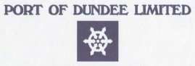

Port of Dundee

Marine Hub

Fish Dock Road

Dundee

DD1 3LZ

**Tel: 01382 878141**

**Email:** [**ftns@forthports.co.uk**](mailto:ftns@forthports.co.uk)

# 

# Contents

Distribution list i

Fast Fact Sheet………………………………………………………………………..ii

Glossary………….. iii

Consultation Statements vi

Part 1: Strategy 1

Section 1: Introduction 1

1.1 Purpose of Plan 1

1.2 Use of plan 2

1.3 Statutory Harbour Authority Area 2

1.4 Scope of Plan 4

1.5 Identification of the roles & Responsibilities of Parties Associated with the Plan 5

1.5.1 Oil Pollution Responsibilities 6

1.5.2 Roles and Responsibilities of associated authorities 7

1.5.3 Vessels in Transit 7

1.6 Overarching response strategy 7

1.7 Categories of Incident 8

1.7.1 Levels of Call-out 8

1.8 Waste Disposal Procedures 8

1.8.1 Consultations 9

1.8.2 Checklist for Waste Management 9

1.8.3 Waste Minimisation 13

1.9 Document Control and Plan Revision 13

Section 2: Risk Assessment 14

2.1 Scope of Assessment 14

2.2 Methodology 14

2.3 Historical Data 15

2.4 Risk Rating 15

2.5 Pre Arrival Checks 16

2.6 Risk Analysis 17

2.6.1 Passage and Berthing within the Harbour 17

2.6.2 Berthing or Sailing Operations 17

2.6.3 Terminal Operations (Nynas UK) 18

2.6.4 Bunkering Operations 19

2.6.5 Potential Sources of Oil Spillage 19

2.6.6 Scenario Assessment for Largest Vessel Capable of Entering the Harbour (Example- a Place of refuge) 19

2.6.7 Response Strategy 20

2.6.8 Overall Conclusion 20

Section 3: Training and Exercise Policy 22

3.1 Training Policy 22

3.2 Exercise Programme 23

3.4 MCA Post Exercise Proforma 25

Section 4: Incident Response Organisation 26

4.1 Introduction 26

4.2 Responsibilities and Incident Control Arrangements 26

4.2.1 Port of Dundee Harbour Master/Marine Manager 26

4.2.2 The Response Team Members comprise of: 27

Position 27

Duty 27

Port of Dundee Harbour Master / Marine Manager 27

Incident Controller 27

Marine Manager / Marine Officer 27

On-scene commander 27

Port Marine Assistant / Pilot Vessel Coxswain / Port Personnel 27

Personnel Clean-up Operations 27

4.3 Dispersant Use 27

4.4 Interface with other Contingency / Emergency Plans 28

4.5 Internal Alerting and Call-out Procedures 28

4.6 Liaison Procedures with Other Agencies 29

4.7 Incidents Involving Mobilisation of Response Cells and SOSREP 30

4.7.1 The Secretary of State’s Representative 30

4.7.2 Intervention 31

4.7.3 Establishment of response cells 31

Composition of the Salvage Control Unit 32

4.7.4 Places of Refuge 33

Section 5: Response Strategies 34

5.1 Spill Assessment 34

5.1.1 Introduction 34

5.1.2 Initial Evaluation Checkpoints 34

5.1.3 Slick Predictions 35

5.1.4 Oil Quantity Estimation Guide 37

5.1.5 Spilt Oil Sampling 39

5.1.6.1 Identifying Dispersed Oil 40

5.1.6.2 Observing When Dispersion Has Occurred 41

5.1.6.3 Field Testing for Dispersability of Spilt Oil 42

5.1.7 Aerial Surveillance 42

5.1.7.1 Flight Plan 43

5.2 Health and Safety Guidance 43

5.2.1 Safety Guidelines for Initial On-Site Assessment 44

5.2.2 Safety Measures for On-Site Response Personnel (including visitors and the general public) 45

5.2.3 Personal Protective Equipment 45

5.2.4 Open Water Response Safety Tips 46

5.2.6 Health Effects of Exposure to Spilt Hydrocarbons 47

5.2.7 First Aid for Contact with or Ingestion of Oils and Dispersants 47

5.2.7.1 Eyes 47

5.2.7.2 Ingestion 48

5.2.7.3 Skin Contact 48

5.2.7.4 General Hygiene 48

5.2.8 Environment 48

5.3 Scientific,Technical & Operational Advice Notes 49

5.4 Response Procedures 49

5.4.1 Natural Dispersion & Response Checklist 50

5.4.2 Chemical Dispersion Response Option Checklist 52

5.4.3 Mechanical Containment and Recovery & Coastal Protection Response Checklist 53

5.5 Disposal Plan 55

Part 2: Actions & Operations 57

Section 6: Action Sheets 57

6.1 Observer of the Incident Report 57

6.2 Harbour Master / Marine Manager - Initial Response Upon Notification of a Spill 59

59

6.2.1 Harbour Master / Marine Manager - Action Sheet 60

6.2.2 Escalation of Response 61

6.3 Port of Dundee Port Manager 62

Section 7: Communications 63

7.1 Notification Matrix 63

7.2 Communications and Reporting 64

7.2.1 Reporting of Oil Pollution 64

7.2.2 Communications 64

7.2.3 Records 64

Section 8: Sensitive Areas Response Information 65

8.1 Sites of Special Scientific Interest 65

8.2 Special Areas of Conservation (SAC) 65

8.3 Special Protection Areas (SPAs) 66

8.4 Fisheries 67

8.5 Tidal Data 68

Section 9: Report Forms and Checklists 68

9.1 POLREP Pollution Report Form 68

9.2 Incident Log Sheet 71

9.3 Waste Disposal Action Checklist 72

9.3.1 Oily waste generated from a shoreline clean-up operation 72

9.3.2 Oily liquids recovered at sea and held on a dedicated oil recovery vessel 73

Section 10: Press and Public Information 74

10.1 Media Liaison 74

10.2 The Media’s Needs 74

10.3 Objectives in Dealing with the Media 74

10.4 Sample Press Statements 75

Part 3: Data Directory 76

Section 11: Resources Directory 76

11.1 Tier 1 76

11.2 Tier 2 77

11.3 Available Watercraft 78

Section 12: Product Information Sheets 79

12.1 Product Information Sheets 79

Appendix 1– SSSI Citations 81

Appendix 2- Overview of Designations 99

Appendix 3- Emergency Contacts Directory 104

**Record of Amendments**

|  |  |  |  |
| --- | --- | --- | --- |
| AMENDMENT NUMBER | DATE | PAGE NUMBERS AMENDED | AMENDED BY |
| 1 | December2023 | Full Review | C.Campbell |
|  |  |  |  |
|  |  |  |  |
|  |  |  |  |
|  |  |  |  |
|  |  |  |  |
|  |  |  |  |
|  |  |  |  |
|  |  |  |  |
|  |  |  |  |
|  |  |  |  |
|  |  |  |  |
|  |  |  |  |
|  |  |  |  |
|  |  |  |  |
|  |  |  |  |
|  |  |  |  |
|  |  |  |  |
|  |  |  |  |
|  |  |  |  |
|  |  |  |  |
|  |  |  |  |

### Dundee OPRC PLAN

Distribution List

* Adler and Allan
* Angus Council
* Dundee City Council
* Fife Council
* Forth Ports Marine Team
* Forth Ports website
* MAIB
* Marine Directorate
* MCGA Counter Pollution Officer
* MRCC Aberdeen
* NatureScot
* Nynas
* Perth and Kinross Council
* Police Scotland
* Scottish Fire and Rescue service
* SEPA
* Spreng and Co
* SOSREP
* Targe Towing

|  |  |  |
| --- | --- | --- |
| ***Quick info sheet - Dundee*** | | |
|  | | |
| Harbour Master | *Johnnie Cowie* | |
| Harbour Office contact details | *Marine Hub*  *Fish Dock Road*  *Dundee*  *DD1 3LZ* | |
| Telephone:  Telephone (24h)  e-mail:  web site: | 01382 878141  01324 498584  DundeeMarine@forthports.co.uk  www.forthports.co.uk |
| Latitude & Longitude – *harbour entrance* | 56 27.72N 002 57.10W | |
| Admiralty chart numbers | 1481: RIVER TAY DUNDEE AND APPROACHES  5617_14: RIVER TAY TAYPORT TO DUNDEE | |
| Maximum available draft | 8.8 metres | |
| Maximum available length | 190 metres | |
| Maximum beam – *if applicable* | 35 metres | |
| Navigational access – *ie.* *leading lights, buoyage* | Fairway buoy at River Tay entrance. Newcome buoy. Leading light. | |
| Environmental Sensitivities | **Sites of Special Scientific Interest**: Inner Tay Estuary / Balmerino – Wormit shore / Tayport – Tentsmuir Coast / Monifieth Bay / Barry Links  **Special Areas of Conservation** - Firth of Tay / Eden estuary  **Special Protection Area** - Firth of Tay and Eden Estuary | |
| Tugs | None permanently based in Dundee | |
| Pilotage | For vessels with length >40m | |
| Anchorages | Buddon Anchorage | |
| Repair facilities – *ie. dry docks and slipways* | None | |
| Cargo handling facilities – *ie bulk, fuel, containers* | Rigs, Bulk, Cruise and Oil. | |
| Local authority | Dundee Council | |
| Hazards – *pipelines, overhead cables* | Gas Pipeline - Monifieth to Tayport | |
| Tidal Range | CD 0.0m / LAT 0.2m / HAT 6.2m | |
| ISPS compliant | Yes | |

### Glossary

|  |  |
| --- | --- |
| **Glossary** | |
| A&A | Adler and Allan Limited |
| DCC | Dundee City Council |
| DfT | Department for Transport |
| HFO | Heavy Fuel Oil |
| HMRC | Her Majesty’s Revenue and Customs |
| HWS | High Water Springs |
| IMO | International Maritime Organisation |
| JNCC | Joint Nature Conservation Committee |
| LA | Local Authority |
| LFO | Light Fuel Oil |
| LWS | Low water Springs |
| MCA | Maritime and Coastguard Agency |
| MFO | Medium Fuel Oil |
| MGO | Marine Gas Oil |
| MRCC | Maritime Rescue Coordination Centre |
| NCP | National Contingency Plan |
| OPRC | Oil Pollution Preparedness Response and Co-operation Convention |
| OSCP | Oil Spill Contingency Plan |
| PoR | Place of Refuge |
| SEPA | Scottish Environment Protection Agency |
| SSSI | Site of Special Scientific Interest |
| UKPIA | United Kingdom Petroleum Industry Association |

**Statements of Consultees**

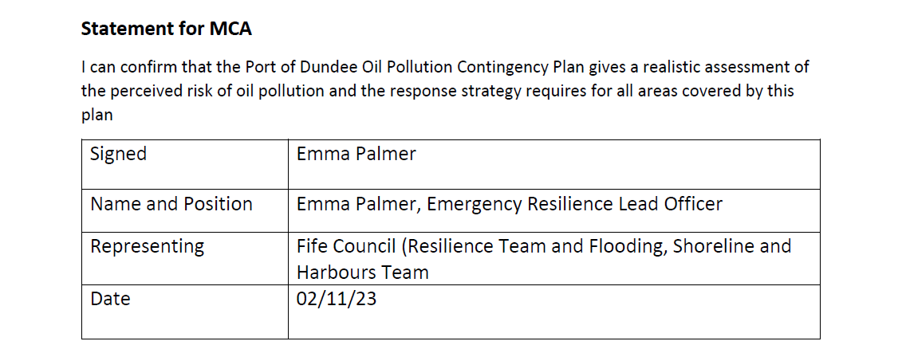

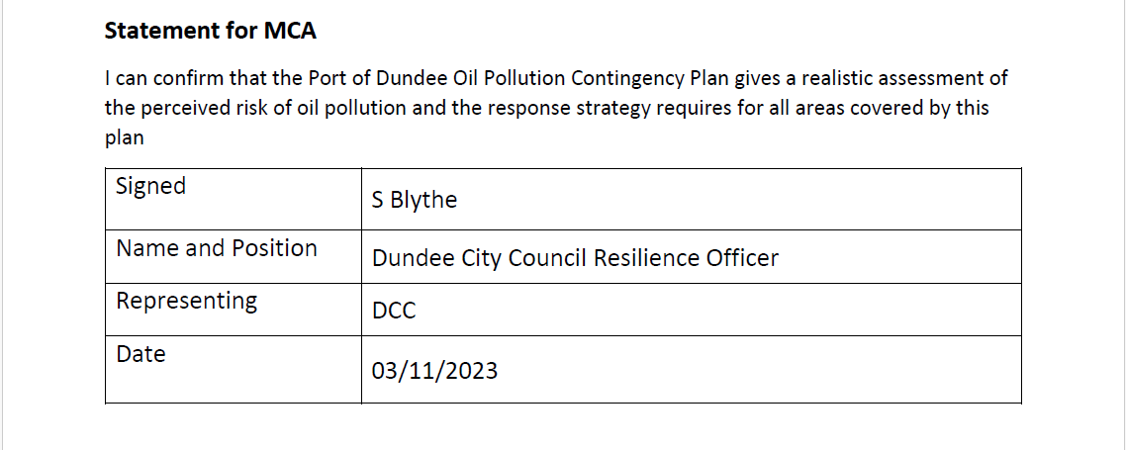

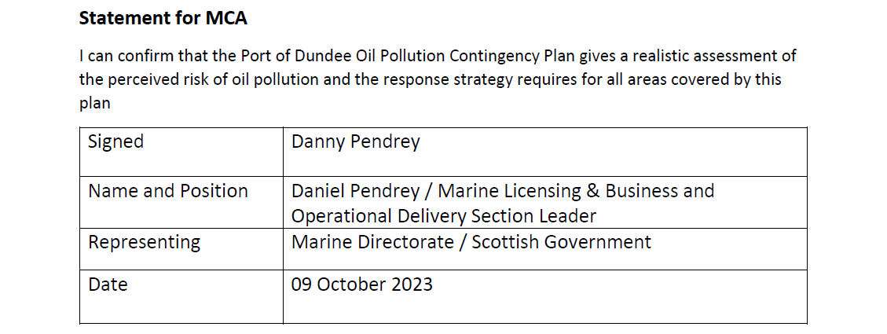

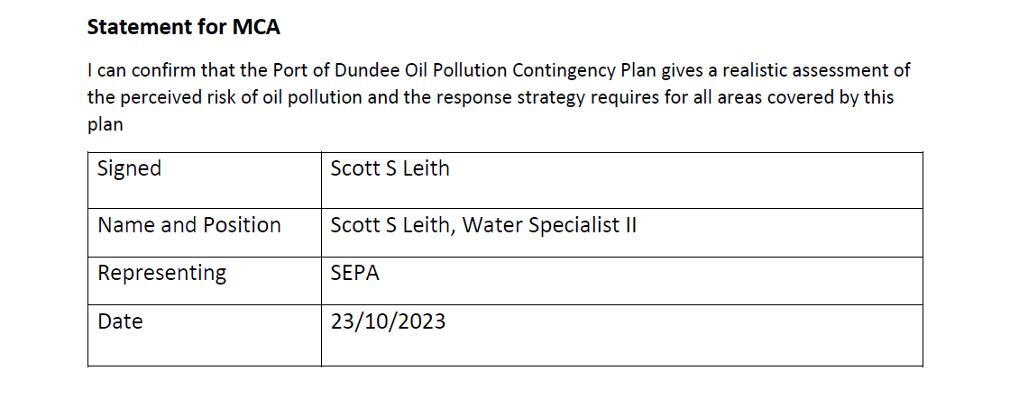

### Forth Ports Policy Documentation

As part of Forth Ports Limited the Marine Department is committed to fulfilling its environmental duties as required by the Harbours Act 1964 and other relevant legislation. Ports are required by Government policy to adopt an appropriate balance between conservation of the environment and enabling sustainable economic growth.

Forth Ports Marine Department provides provisions for navigational safety and Conservancy in the Firths of Forth and Tay including Pilotage and Towage services. To fulfil its’ commitment to continual environmental improvement Forth Ports Marine Department aim to set, implement and regularly review the following objectives:-

* Ensure that all of our activities at least match legal & other requirements and where possible exceed these requirements.
* Undertake and regulate marine movements in such a way as to safeguard water users, the marine and adjacent land environment and local communities.
* Regularly exercise contingency plans (whether pollution prevention or emergency plans) and where appropriate implement any lessons learnt from these exercises.
* Where required, undertake appropriate assessments under the Habitats Directive for new projects.
* Where appropriate, consult with relevant statutory authorities, regulators and stakeholders, where there are areas of common interest.
* Maintain membership of the Forth Estuary Forum and Tay Estuary Forum and take an active role in the management of these organisations and the initiatives they develop.
* Ensure that all waste is disposed of responsibly, or where practical recycled or re-used
* Communicate this Environmental Policy to all staff and provide guidance and appropriate training where necessary.
* Review this Policy at regular intervals.

Chief Harbour Master

# Part 1: Strategy

## Section 1: Introduction

### Purpose of Plan

This Oil Spill Contingency Plan is designed to guide the Port of Dundee Limited’s response personnel at Dundee Port through the processes required to manage an oil spill originating from operations within or approaching their Port.

The requirement to have an Oil Spill Contingency Plan for Harbours, Ports and Oil Handling Terminals around UK waters has been formalized by the Merchant Shipping (Oil Pollution Preparedness, Response and Co-operation Convention) Regulations 1998, which implements the International Convention on Oil Pollution Preparedness, Response and Co-operation, 1990 (OPRC, 1990). The convention, adopted by the International Maritime Organisation (IMO) is aimed to “mitigate the consequences of major oil pollution incidents involving, in particular, ships, offshore units, sea ports and oil handling facilities”. The Port of Dundee will however use their resources to assist in responding to non-marine related oil pollution incidents.

This plan has been prepared in accordance with the “Contingency Planning for Marine Pollution Preparedness and Response Guidelines for Ports “issued by the Maritime and Coastguard Agency who are responsible for applying the regulations to all harbours, Ports and oil handling facilities in the UK.

The Port of Dundee is owned and operated by Forth Ports Limited. The responsibility for the maintenance of the plan rests with the Harbour Master of the Port of Dundee. The plan will be reviewed on a yearly basis or after any incident/exercise. Every five years the Harbour Master will submit the plan in its entirety to the MCA for approval.

**Consultation**

This document has been compiled in consultation with the following statutory bodies and Authorities:

* Scottish Environment Protection Agency (SEPA)
* NatureScot
* Marine Directorate
* Port of Dundee Limited
* Dundee City Council
* Angus Council
* Fife Council
* Perth and Kinross Council

### Use of plan

This plan is specifically for operations within the Port of Dundee, the associated pilotage area and for vessels passing through the Port of Dundee Limited’s boundaries. The plan is designed to initiate an appropriate oil spill response in the event of an incident. It details a tiered response strategy that is in accordance with UK legislative requirements and takes into account the spill risk associated with the operation; the nature of the hydrocarbons that could be spilt; the prevailing meteorological and hydrographic conditions and the environmental sensitivity of the surrounding areas.

### Statutory Harbour Authority Area

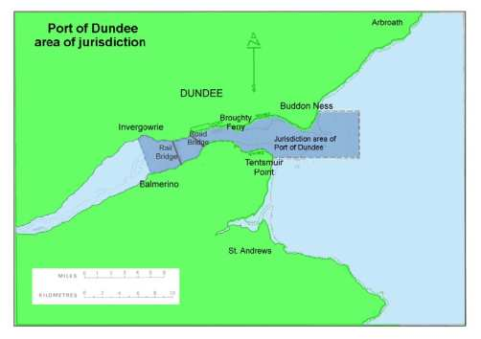

**Map of Harbour Limits**

**PLAN OF HARBOUR**

|  |  |  |  |  |
| --- | --- | --- | --- | --- |
| **No.** | **Wharf/Facility** | **LOA** | **Quay Edge** | **Ruling Depths** |
| **1** | King George V Wharf | 445m | 7.22 | 7.6m |
| **2** | Caledon West Wharf (Bitumen and Bunkering Berth) | 76m | 7.2 | 8.8m |
| **3** | Princess Alexandra Wharf | 256m | 7.0 | 8.0m |
| **4** | Eastern Wharf | 213m | 7.0 | 7.5m |
| **5** | Tidal Basin | N/A | - | N/A |
| **6** | DunEcoQuay | 170m | 7.0 | 9.0m |
| **7** | Prince Charles Wharf | 312m | 7.0 | 8.6m |

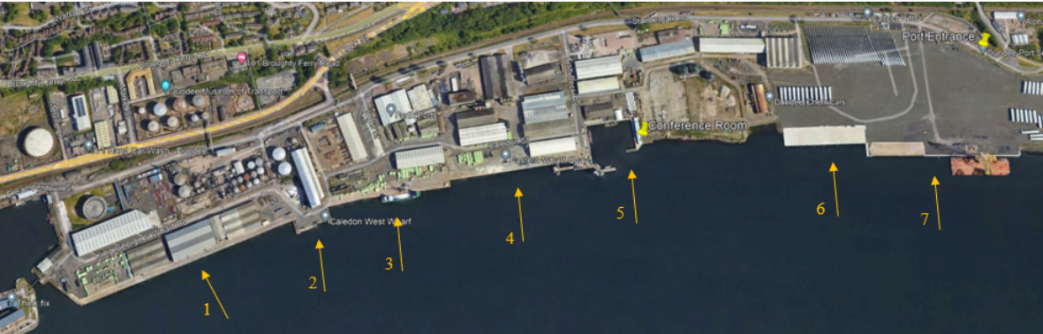

### Scope of Plan

This Plan has been compiled to cover the response to any spillage caused by or during operations associated with safe passage to or from the Port of Dundee and within the jurisdiction of the Port of Dundee.

The scope of the plan covers response to all the “essential elements” contained within the MCA Oil Spill Contingency Guidelines for Ports, Harbours & Oil Handling Facilities.

The plan indicates the Tier 1 response available in the Port relevant to the perceived risk through normal operations as well as a mechanism for calling upon Tier 2 or 3 responses in the event of an abnormal incident or major accident. A definition of the tiered levels used in the Port is shown below and the process of response escalation is described in Section 6.

Table 1 Tiered Response Levels

|  |  |
| --- | --- |
| Response Tier | Definition |
| Contained Operational Spills | These are spills, which are contained on the ship or dockside and do not enter the water. |
| Tier 1: | Small operational spills that may occur within a location as a result of daily activities. The level at which events can be controlled using on site resources. A Tier 1 spill is not likely to require recourse to intervention by resources out with the Harbour, an external incident response organisation or external authorities, except for purposes of notification. |
| Tier 2: | Medium sized spills within Dundee Port that will be handled by Port Personnel and a nominated contractor or other external assistance (including relevant Local authority resources) as nominated within this plan. Oil spill response to be co-ordinated via the Port or Local Authority |
| Tier 3: | Larger spills or a loss of containment incident that will require full involvement of other authorities and possible mobilisation of Tier 3 and national stockpiles. A Tier 3 incident is beyond the capabilities of both local and regional resources. |

### Identification of the roles & Responsibilities of Parties Associated with the Plan

In the U.K. there is an established national system in place for responding promptly to oil pollution incidents with this system detailed in the National Contingency Plan. The Maritime and Coastguard Agency (MCA) is the competent U.K. authority responsible for responding to pollution from shipping and offshore installations and for implementing the National Contingency Plan. The “*National Contingency Plan for Marine Pollution from Shipping and Offshore Installations”* (NCP) was first published in January 2000, and was reviewed and reissued in December 2006, further review took place in 2014 and 2017 and the plan sets out revised command and control procedures for incident response following Lord Donaldson’s Review of Salvage and Intervention and their Command and Control. These procedures have built-in thresholds to allow for flexibility of response to different degrees of incident.

This system as it applies to harbour areas has oil pollution responsibilities shared amongst:

* Harbour and port authorities
* Oil handling facilities
* Government Departments and Agencies:
  + Maritime & Coastguard Agency (MCA)
  + Scottish Environment Protection Agency (SEPA)
  + Marine Directorate
  + NatureScot
* Maritime local authorities.

The oil pollution responsibilities of these organisations are summarised in section 1.5.1.

#### 1.5.1 Oil Pollution Responsibilities

**UK National Contingency Plan**

**Definition of Roles and Responsibilities**

HM Coastguard

Co-ordinates maritime search and rescue.

Provides early warning system for oil pollution and will assess spill reports and alert Counter Pollution & Salvage Officers.

Maritime and Coastguard Agency

Will co-ordinate government response to Tier 3 and implement National Contingency Plan.

Mobilise government equipment resources.

Would set up Salvage Control Unit (SCU) if deemed necessary.

Scottish Environment Protection Agency

SEPA is responsible for licensing discharges to the water environment, except for discharges from vessels dealt with by the MCA, and the carriage of waste.

SEPA also has duties requiring it to protect designated sites of nature conservation importance and to further the conservation of biodiversity through the exercising of its functions.

SEPA will regulate and licence the storage and transportation of any waste products collected as a result of any clean up operations.

Master of Vessel

* Reports spill to Harbour Authority
* Acts in accordance with Shipboard Oil Pollution Emergency Plan

Nature Scot

Lead conservation body with respect to oil pollution incidents within 12 mile territorial limit.

Will provide advice on the implications of marine pollution or any proposed clean-up actions on wildlife and habitats to relevant authorities including Forth Ports, MCA, Marine Directorate and local authorities.

Consultee to Marine Directorate re dispersal use in restricted use areas.

Will form part of Environment Group if triggered.

**Port and Harbour Authorities**

Responsible for control and clean-up of water borne spills in harbour / port/ dock waters / navigable waters of the River Tay.

Responsible for and implementation of approved harbour oil spill contingency plan.

Responsible for reporting spill to HM Coastguard.

Responsible for implementing oil spill plan and maintaining document.

Responsible for implementation of Tier 2 response and availability of resources for the response.

MARINE DIRECTORATE

Under the provision of Part 4 of the Marine (Scotland) Act 2010.

Marine Directorate should be consulted in all other situations except ‘force majeure’.

Early consultation r.e. use of dispersants in areas outwith above restriction.

Will form part of Environment Group if set up.

Oil Handling Facilities

Responsible for reporting all spills into harbour waters to the Harbour Authority.

Responsible for responding to Tier 1 spills.

Maritime Local Authorities

Have assumed responsibility for clean-up of the shoreline. (including land exposed by falling tide)

#### 1.5.2 Roles and Responsibilities of associated authorities

The Port of Dundee Marine Department is operated by the Port of Dundee Limited appointed Marine Manager. In the event of an oil spill incident, the Chief Harbour Master or his deputy will be responsible for the overall co­ordination of the spill response.

#### Vessels in Transit

The statutory duty for reporting and dealing with pollution from any vessel en route to the Port of Dundee, or travelling further up the Tay to Perth, lies with the Master and vessel owners. After commencing entrance to the Port of Dundee through the designated area of jurisdiction covered by this plan, reporting and response to any pollution incident will be co-ordinated through the Port of Dundee Limited’s Oil Spill Contingency Plan.

Perth Harbour maintains responsibility from the western Port of Dundee Limits to Perth.

The roles and responsibilities of all authorities requiring notification in the event of a spill and the appropriate paths of communication to be followed in the event of a spill are shown in Section 7 of this plan.

### 1.6 Overarching response strategy

Where possible, considering safety, environmental sensitivity and estuarine conditions, any floating oil on the water surface should be removed physically – no chemical dispersants are to be used. Removal should particularly be attempted where this may significantly reduce the possibility of quantities of oil coming ashore on areas of recreational and environmental importance or sensitivity, such areas are detailed in section 8 and appendices 1 & 2

Where access to shoreline is possible, considering safety, environmental sensitivity and estuarine conditions; mechanical methods to clean up oil may be used. Otherwise oil should be left to degrade naturally.

Where oil comes ashore it should be removed by manual and mechanical means whenever possible.

### 1.7 Categories of Incident

The Port of Dundee has in place a tiered incident response system for oil spillage (Section 1.4). The responsibility of escalating an incident from Tier 1 to Tier 2 lies with the Marine Manager.

#### 1.7.1 Levels of Call-out

*Tier 1 Spills*

For minor spills, where the response is addressed within the Port, the Marine Manager will take the appropriate action and arrange for safe storage and legal disposal of waste arising. Since all oil spills, regardless of size, have to be reported to the appropriate authorities, the Marine Manager, and/or Port Manager, will always alert the MCA.

*Tier 2 and Tier 3 Spills*

For all spills of a higher level, the Marine Manager will alert the incident response organization according to this plan.

### 1.8 Waste Disposal Procedures

A natural dispersion or chemical dispersion response strategy or chemical dispersion may remove oil from the sea surface and prevent oil beaching. In the event of a containment and recovery strategy either water borne offshore or near shore will result in generation of oily waste.

Recovery operations potentially give rise to a large quantity of waste oil and water for treatment. The type of spilled oil will have an effect on the resultant waste. Viscous and waxy oils will entrain debris and create large waste volumes.

Wastes generated may include:

* Recovered oil
* Oily water
* Oiled equipment
* Oiled PPE
* Oiled vegetation
* Oiled sorbents
* Oiled flotsam

In the event that waste generation occurs the following will be required:

* Arrangements for the storage of recovered oil offshore;
* Arrangements for the collection, transport and disposal of oil and oiled wastes.
* Characterisation of oiled wastes in order to aid identification of most appropriate waste disposal facilities to handle the waste materials.
* Preparation of all necessary documentation and pre-notifications necessary to satisfy the Duty of Care and, if necessary, Special Waste regulations.

Arrangements for waste disposal shall be the responsibility of the Tier 2 service provider.

#### 1.8.1 Consultations

This will form an integral part of the waste management plan in order to determine:

* Where waste may be landed in what form
* Decisions on on-site storage and method
* Availability of suitable waste carriers
* Consideration of potential final resting place
* Proximity, capacity and license of range of treatment and disposal facilities

#### 1.8.2 Checklist for Waste Management

* Make initial contact with possible waste disposal facility operators to make arrangements for the ultimate disposal of waste materials. Note that close-sided lorries and skip-trucks can be used for non-liquid wastes, and specialist vacuum trucks (flash point dependent) and gully suckers are best for liquid oily wastes. If necessary, flat bed lorries can be used for either type of oily waste by transporting the materials in tanks or drums fitted with temporary covers.
* Ensure that all hauliers’ vehicles are carrying valid Registered Carriers Registration Certificates before they arrive on-scene.
* Obtain data on likely quantities of liquid oily wastes that are being collected by any recovery operations.
* Estimate quantities of non-liquid oiled wastes created primarily on shorelines. Initiate appropriate Duty of Care and Special Waste documentation to cover all waste transport used and ensure that the destination of the oiled wastes is extremely clear to the lorry drivers. Shoreline waste is the responsibility of the Local Authority – this is an issue the Environment Group will be looking at on a case by case basis.
* Ensure that transport of oily wastes is of a frequency sufficient to prevent the temporary storage being overwhelmed.
* Confirm with all waste disposal facilities used that they have received all documentation required to cover the movement of oiled wastes to their facilities.
* Oil spill wastes are considered to be hazardous wastes and are subject to the Waste Managing Licensing (Scotland) Regulations 2011. However, oil collected during response activities can be stored temporarily at the site in accordance with Waste Management Licensing Exemption 41 (which allows storage of waste at the place of production).
* Plans for handling and temporary storage of wastes during the oil spill response must be discussed with the Scottish Environment Protection Agency (SEPA) at the earliest opportunity.
* Any recovered oil should be reported to HM Customs as advised in the oil spill reporting table provided in Section 5.
* The disposal site for the waste MUST hold a licence to receive the type of oily waste that you are sending to it.
* It is the responsibility of all parties involved to ensure the site is licensed to receive waste.
* The responsibility for complying with regulations is divided between the Harbour Authority / Port for waste generated on the water surface in whose jurisdiction the spill has occurred and the local authority if there is shoreline clean-up and those involved in its movement and reprocessing, storage and disposal.
* In the event of containment and recovery at sea and shipping of oil onshore for disposal, the responsibility for complying with the waste legislation lies with the port who is recognised as the waste producer.
* Where the oil has beached and the local authority is conducting a beach clean-up operation and are sending the waste for disposal, the local authority become the waste producer and are the body responsibility for the waste paperwork, registered carrier checking.

Marine oil waste disposal regulatory controls by SEPA are summarised in the diagram and the key on the following pages.

KEY

|  |  |  |  |  |  |  |
| --- | --- | --- | --- | --- | --- | --- |
| Key | REGULATORY CONTROLS | | * Not specifically SEPA  WML – Waste Management Licence | | | |
| **1.** | **Duty of Care\***  **S.34 EPA 1990 (NB Applies from 1. to 8. irrespective of other controls;** | | | | | |
| **2i.** | **Temporary Storage**  **“Emergency” provisions apply,**  **No WML required;** |  | | |  | |
| **2ii.** | **Longer Term Storage**  **WML required;** | | | | | |
| **3.** | **Existing Local Holding Facilities (Tankage)**  **WML required;** | | | | | |
| **4.** | **Waste Movement By Road**  **Registered Waste Carriers,**  **Waste consigned under Special Waste Regs. 1996;** | | | | | |
| **5.** | **Intermediate Storage (e.g. old airfields)**  **Planning approval,**  **WML required;** | | |  | |  |
| **6.** | **Land Farming**  **Site specific risk assessment,**  **WML required,** | | | | | |
| **7.** | **Treatment/Recovery**  **WML or authorisation under Part I EPA required;** | | | | | |
| **8.** | **Landfill Disposal**  **Suitably licensed sites only**  **Must be engineering containment,**  **Loading limits on oil input will apply.** | | | | | |



#### 1.8.3 Waste Minimisation

Minimisation is a method of reducing the amount of waste entering the waste stream. This can reduce the amount of waste for final disposal and also limit environmental and economic impacts. Efficient methods should be developed for oil spill clean up to ensure that the minimum material is used and/or contaminated during the process.

There are a number of methods that can be used for this:

* Recovery equipment should be cleaned and reused rather than discarded.
* Reusable personal protective equipment (PPE) should be utilised where appropriate (e.g. rubber boots can be cleaned and reused).
* Sorbents should be used sparingly and effectively.
* Production of a marketable product from waste, e.g. taking waste oil to a refinery (Grangemouth Refinery) for conversion into other usable products.

Refuse is the final and least desirable option. If none of the above methods can be carried out for whatever reason the waste must be disposed of effectively following guidance from SEPA.

### 1.9 Document Control and Plan Revision

The Port of Dundee’s Oil Spill Contingency Plan is a controlled document.

Any changes to the situation at the harbour, changes to be made to the plan or any updates will be issued as amendments to all holders of the plan within 3 months of such change. Irrespective, the plan will be revised on an annual basis so as to incorporate changes occurring during the year plus lessons learned from the annual exercise.

This document has an approved life span of 5 years from the date of approval by MCA and it shall be submitted in its entirety for re-approval at that time.

## Section 2: Risk Assessment

A risk assessment to meet with OPRC Contingency planning requirements for Ports and terminals has been completed by Adler and Allan Limited (A&A) on the basis of format previously agreed with the Maritime Coastguard Agency (MCA).

NYNAS Terminal is a COMAH Lower Tier site and also has a Major Accident Risk Assessment with details of environmental accidents/oil spills.

### 2.1 Scope of Assessment

This assessment covers operations carried out within the jurisdiction of the Port of Dundee, operated by the Port of Dundee Limited. The area of jurisdiction is as shown in Section 1.3.

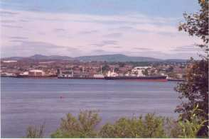

**The Port of Dundee from the south bank of the Firth of Tay**

### 2.2 Methodology

This risk assessment is designed to identify potential oil sources, the size of potential spills and to estimate the risk associated with events that may result in a release of oil into the marine environment. In order to assess the consequences and subsequent overall risk acceptance criteria of a spill, it is important to identify the major oil containing systems associated with harbour operations. All oil containing systems (source) connected with the harbour operations, initiating events that could result in an accidental spillage and the potential maximum quantity (inventory) that could be released were identified and examined.

The control measures in place reduce the risk of oil spillage associated with the harbour operations. Therefore the full range of control measures implemented by Port of Dundee to minimise the risk of an oil spill event have been considered for each pier and slipway.

### 2.3 Historical Data

Historical data is not available for oil spills within ports and harbours and as a result this risk assessment is based on operational and technical criteria, supplied by the Port of Dundee.

### 2.4 Risk Rating

The environmental risk assessment has been undertaken using a qualitative approach. The following categories ranging from ‘Low’ to ‘High’ have been used to indicate the risk of pollution to the environment. A description of the ratings categories is provided in the following table:

Table 2 Risk Rating

|  |  |
| --- | --- |
| **RISK RATING** | **DEFINITION** |
| **Low Risk** | No legal implications. No noticeable environmental impact. No additional controls required. |
| **Moderate Risk** | Breach of legislation with the potential for fines. Minor to moderate environmental damage to the local area, minor risk to humans and wildlife or contribution to cumulative environmental pollution problems. Damage likely to have a moderate cost implication. |
| **High Risk** | Breach of legislation with potential for large fines or prosecution. Environmental damage of high significance. Damage likely to have a high cost implication. Risk to health of people and wildlife. |

The Port of Dundee is located on the north bank of the Firth of Tay, 1.6 km from the city centre. An extensive area of Wharves, 1400 metres long, is immediately downstream of the Tay Road Bridge. The Port office is located on Stannergate Road just east of the west security gate and the Port control is located at Forth and Tay Navigation Service. The Port offers extensive warehousing that stores products such as fertiliser, timber and agricultural products.

There are 6 main wharfs available for berthing, all are common use, anchoring is possible within the river and offshore.

Repairs are possible while a vessel is alongside, no drydock is available in the port.

The Port of Dundee facilitates circa 500 ship movements per year. The table below demonstrates the quantities and types of cargoes handle by various vessels at the Port of Dundee.

Table 3 Numbers of Moves by Vessel Category

|  |  |
| --- | --- |
| **Vessel Category** | **Number of Moves** |
| Tankers | 70 |
| Dry Cargo | 215 |
| Rigs/Barges | 14 |
| Oil Support | 81 |
| Cruise | 8 |
| Other | 77 |
| **TOTAL** | **465** |

Table 4 Numbers of Moves by Vessel Category

|  |  |
| --- | --- |
| **Cargo Type** | **Cargo Quantity (MT)** |
| Forest Products | 29,850 |
| Agricultural Products | 227,038 |
| Oil Products | 86,557 |
| Other Dry Bulk | 190,550 |
| Other Packaged Cargo | 4,791 |
| **TOTAL** | **538,786** |

The above figures reflect movements in 2022 in Port of Dundee.

The Nynas Camperdown terminal receives fuel oils and bitumen, fuel oils and heavy gas oils. Caledon West Wharf (Bitumen and bunkering berth) is mainly used for all tanker traffic. These products are imported to the Nynas terminal, which is located in East Camperdown Street in the Port. Tankers tie up and discharge their cargoes at Caledon West Wharf via ducted pipelines that are above ground level via various shut-off valves into the refinery.

### 2.5 Pre Arrival Checks

Control of vessels is carried out by Forth and Tay Navigation Service which discusses passage and berthing with all vessels prior to their entry into the harbour. Pilotage is required as per the Pilotage Directions. The date and time of arrival of all vessels calling at the Port of Dundee is arranged with shipping agents who advise the Port by email or fax several days in advance. This ensures a pilot is available to board vessels prior to entering the Port. The pilot vessel is only on duty when vessels are expected. All vessels are required to report their operational condition in accordance with statutory regulations (Schedule 2), 24 hours prior to arrival; this is normally carried out via the ship’s agent.

Under the terms of Chapter IX of SOLAS there is a mandatory enforcement of the ISM code (International Management Code for the Safe Operation of Ships and for Pollution Prevention). The international requirements require that all vessels (including cargo ships and Mobile Offshore Units all of 500 GRT and over) were compliant by the 1st of July 2002.

Following implementation of the Port Marine Safety Code (PMSC), a full risk assessment based on ALARP principle is carried out along with producing a formal safety management system and developing policies and procedures in accordance with the standards of the Code. Port passage plans have also been developed with a Pilot / Master checklist which is carried out to all vessels by the duty Pilot. The Ports and Pilots copies of the checklist are filed for future reference.

### 2.6 Risk Analysis

The Port of Dundee maintains, reviews and updates a comprehensive folio of Marine Risk Assessments as part of the Port Marine Safety Code which cover all aspects of the marine operations from initial arrival through to berthing and if applicable bunkering. The risk of pollution is assessed fully within these risk assessments and can be found on the Forth Ports Website [*http://www.forthports.co.uk/marine/safety/*](http://www.forthports.co.uk/marine/safety/)

#### 2.6.1 Passage and Berthing within the Harbour

The Port is approached by a well-defined main channel with up to date navigational aids including radar surveillance. Passage into the Port is restricted due to a depth of 6.0 metres at the bar 5.6 metres depth in a virtual channel at Lady Shoal at LAT. The Port can handle vessels in excess of300 metres LOA.

#### 2.6.2 Berthing or Sailing Operations

For all berthing or sailing operations, comprehensive marine guidelines are published in the Port of Dundee Marine Guidelines and Port Information.

**Berthing Failure or Collision – Conclusion**

Berthing Failure is considered to be a low-level risk, due to the size of vessel able to use the harbour, tugs in attendance and the harbour controls in place. The result of collision damage to the largest cargo fuel tank, based upon the size of vessel that utilise the harbour, taking into consideration hydrostatic pressure is calculated at 250 tonnes of fuel oil.

#### 2.6.3 Terminal Operations (Nynas UK)

Operations are carried out using specialised discharge facilities operated by Nynas. The ducted pipelines run from the wharf to the old refinery on the landward side of the seawall. Flexible hoses are connected directly to the vessel. The hoses are lifted up to the deck of the vessel with the aid of the vessel’s derrick. On the quay, the hoses are manoeuvred on a series of bogeys and then connected to a manifold on the quay. The Nynas facilities are well managed with full bunding of tanks and a water treatment plant which collects surface water before discharge from site. All shore tanks and plant are located in a protected and bunded area and any spill incident would not be expected to cause marine pollution.

All hoses and cargo pipelines are subject to an inspection and a maintenance regime. All tanker operations are carried out in accordance with jetty, harbour and ISGOTT requirements and checklists are used; copies of which are provided to Masters before operations can commence.

During both discharge and loading operations for all types of oil handled, Nynas ensures that the company owned mobile oil spill response kit is on the wharf beside the discharge point. A Nynas contractor mans this kit throughout the discharge/load process and also checks delivery rate of fuel and tank ullage. Nynas also utilises Pre-Loading / Discharge Ship / Shore Safety Checklists. These checklists record product delivery / rate of transfer and which hoses have been used.

Nynas UK also imported the following products (2022):

|  |  |
| --- | --- |
| **PRODUCT** | **IMPORT** |
| Heavy Fuel Oil | 50,000 Tonnes – 12 vessels |
| Bitumen/Bitumen Blend Components | 120,000 Tonnes – 25 vessels |

**Risk assessments for specific HNS can be found in the relevant Product Information Sheets found in Section 12 of this plan.**

#### 2.6.4 Bunkering Operations

Bunkering by road tanker and bunker barge is carried out at all main berths to all types of vessels that call at Dundee as requested. Port of Dundee has a detailed published Bunkering Procedure which all vessels must comply with.

The Port of Dundee does not own/operate any fixed bunkering systems or storage tanks.

**Contents liable to be lost in the event of Hose Failure:**

65 mm diameter hoses are used.

There is a loading rate per hose being approx. 600 litres per minute.

Twin hoses are sometimes used to speed operation.

**Bunkering Failure - Conclusion**

Maximum amount due to overflow or failure is estimated to be 1,200 litres Marine fuel oil.

#### 2.6.5 Potential Sources of Oil Spillage

Potential Port Spillage

* Operational loss < 1,200 litres Marine gas oil
* 75 tonnes FO
* Worst case loss of road tanker 25 tones FO
* Spill during waste oil discharge. Waste oil is discharged by vessels under the Merchant Shipping (Port Waste Reception Facilities) Regulations 1997 (SI No3018). There is a Port Waste Management Plan in operation.
* There are two bunded fuel tanks located within the Port. They are located In the Engineering Workshop which holds 4.0m3; the Tidal Basin holds 10.0m3. The tanks are mainly used for fuelling plant on site and are fuelled by road tankers.

#### 2.6.6 Scenario Assessment for Largest Vessel Capable of Entering the Harbour (Example- a Place of refuge)

Dundee Port would not be considered as a Place of refuge for vessels larger than those already able to enter the Port. The Port is exposed to easterly winds and vessels are more likely to seek shelter in the Firth of Forth.

#### 2.6.7 Response Strategy

Small oil spills within the harbour area will be recovered using Tier 1 materials held by the Port of Dundee and main harbour users. The stocks are to be positioned strategically so as to be readily available at the quayside.

In the event that a Tier 2 spill occurs equipment would be in place within three hours. Port personnel in conjunction with the contractor nominated in this plan would carry out recovery and disposal. Waste arising will be legally carried for disposal.

In the majority of cases, any spillage of the size nominated within this study would be recovered mechanically using sorbents, containment booms and skimmers. It is felt that with relatively little current movement, spilled oil would not spread down the river, the majority of clean-up being effected before any oil impacts on the shoreline.

### 2.6.8 Overall Conclusion

The Port of Dundee as a Statutory Harbour Authority complies with the provisions of the Port Marine Safety Code this compliance being independently audited. Within the Port Marine Safety Code Safety Management System a wide range of procedures based on risk assessment are in place to ensure that risks to vessels, and therefore risks of major and minor liquid hydrocarbon spillages to sea, are reduced to “As Low As Reasonably Practicable” (ALARP). These include the following:

Forth and Tay Navigation Service is staffed 24 hours a day, 365 days a year by a fully qualified Assistant Harbourmaster and a fully qualified VTS Operator The service they provide includes radar surveillance of the Tay Estuary from the Eastern Port Limits. Their duties include enforcement of the Tay Navigation Byelaws. These ensure a safe and speedy passage of all commercial and naval shipping from sea to port and back to sea again.

The Port of Dundee monitors shipping with AIS, CCTV, VHF and Radar. One radar covers the Tay Estuary and is located at Buddon Ness on the North shore of the river. In addition, Forth and Tay Navigation Service personnel monitor meteorological and tide stations located at 2 strategic positions on the Tay and maintain and update an Integrated Port Operating System (IPOS) that records all details of ship voyages in the estuary.

Procedures (including but not restricted to the following):

1. At least 24 hours before a ship arrives on the Tay it must provide pre-arrival information e.g. Name, IMO number etc. A ship must have a passage plan to the port to which they are destined. Checks are made at the Eastern Limits of the Tay and recorded on the VHF, the checks verifying the information sent in the pre-arrival message.
2. If a ship takes bunkers the Bunkering Procedures Rivers Forth and Tay must be complied with, the procedure can be viewed on the Forth Ports website by following the following link:

[*http://www.forthports.co.uk/marine/information/*](http://www.forthports.co.uk/marine/information/)

1. All NtM's can be viewed on the Forth Ports website following the following link: [*http://www.forthports.co.uk/marine/notices-to-mariners/*](http://www.forthports.co.uk/marine/notices-to-mariners/)
2. The Marine Guidelines and Port Information document contains comprehensive guidelines for the safe docking and undocking of vessels in the Harbour Area. This information can also be viewed on the following link: [*http://www.forthports.co.uk/marine/information/*](http://www.forthports.co.uk/marine/information/)
3. Emergency Wharf Response Procedure for NYNAS.

The Port of Dundee is considered to be a very well controlled, low risk harbour. Proper controls exist through set procedures. Although there is vessel movement within the harbour it is well controlled, aided by tugs where required and there are adequate procedures in place to ensure that the chance of an operational spill is considered to be low.

## Section 3: Training and Exercise Policy

### 3.1 Training Policy

The Contingency Planning for Marine Pollution Preparedness and Response Guidelines for Ports state all personnel likely to be involved in a Marine pollution incident have to meet certain requirements and standards. Training should be conducted by an accredited training provider.

In order to familiarise personnel in the use of this Oil Spill Contingency Plan, Oil Spill Response training courses will be held for designated employees of the Port of Dundee, its contractors and Port operators with an identified role within the plan. In addition, there will also be awareness briefings with other harbour users and the agencies who were involved in the consultation process.

After initial training, instruction will be specific with the use of the Tier 1 oil spill response equipment located at the Port of Dundee. This will be tested and deployed using those personnel who will be responsible for operating this equipment in the event of a spill.

The table below illustrates the recommended minimum course length and entry-level criteria for the Port of Dundee.

Table 5 Port of Dundee Plan Training

**PORT OF DUNDEE TRAINING IN T**

|  |  |  |
| --- | --- | --- |
| **POSITION** | **COURSE** | **UK ACCREDITATION LEVEL** |
| Chief Harbour Master | Response Management | MCA 5P |
| Harbour Master Forth & Tay | Response Management | MCA 5P |
| Marine Manager | On Scene Commander | MCA 4P |
| Marine Compliance Manager | On Scene Commander | MCA 4P |
| Assistant Marine Manager | On Scene Commander | MCA 4P |
| Marine Officer | On Scene Commander | MCA 4P |
| Assistant Harbour Master | First Responder | MCA 2P |
| Operations Supervisors | First Responder | MCA 2P |
| Coxswain | First Responder | MCA 2P |
| Port Marine Assistants | Basic Response | MCA 1P |
| All Personnel | Refresher Courses (as reqd) | MCA R |

### 3.2 Exercise Programme

The Contingency Planning for Marine Pollution Preparedness and Response

Guidelines for Ports state:

“Each Port, harbour or oil handling facility must participate in exercises in accordance with the provisions within their OPRC Compliant Oil Spill Contingency plan”

The provisions specific to Dundee Port are detailed in the table below.

**T**

|  |  |  |
| --- | --- | --- |
| **EXERCISE IN THE USE OF THE PLAN** | | |
| **EXERCISE TYPE** | **FREQUENCY** | **TYPE OF EXERCISE** |
| **Notification Exercise** | Twice Yearly | To test, alert and call-out procedures for response teams, test communication systems, availability of personnel, evaluate travel options and arrangements and test the transmission of information. Also can be used to check the validity of contact information within the plan. |
| **Table-top Exercise** (May incorporate mobilisation and deployment of local response equipment) | Annually | During this exercise the capability to respond to a Tier 2 type spill and initiate the primary actions in the event of a Tier 3 response can be put to the test. It tests emergency management knowledge and capability, provides individual and team training, enables personnel to be mobilisation with various roles and their responsibilities within their role and highlights location and response times for resources in the event of an incident. The table-top exercise also explores the interaction between the different parties involved, testing the principles of the response strategies and co-ordination with local authorities and emergency services. |
| Incident Management Exercise (will incorporate mobilisation and deployment of resources up to Tier 2  level) | Every 3 Years | To test the capability of local teams to respond to Tier 1, Tier 2 and Tier 3 type incidents, providing experience of local conditions and spill scenarios, enhancing individual skills and teamwork, integrating the roles of external bodies and organisations. This exercise must as far as possible involve actual organisations to represent a real emergency. However if this cannot be achieved, role-playing personnel can be used to simulate roles and responsibilities. |
| **Revalidation** | 5 Years | Update and test OPRC Plan. |

**3.3 MCA Annual Return Proforma**

**OPRC Annual Return**

|  |  |  |  |  |
| --- | --- | --- | --- | --- |
| **Name of Port, Harbour**  **or Oil Handling Facility**: |  | | | |
| **Annual Return Period:** |  | | **to** |  |
| **Plan Approval date:** |  | | | **(5 year life span of plans)** |
| **Summary of Incidents:** (include date, source, type and quantity of pollution) | | | | |
|  | | | | |
| **Summary of Exercises:** (include date and type of exercise conducted) | | | | |
|  | | | | |
| **Pollution Training Undertaken** (include date, MCA Level, Name & certificate No.) | | | | |
|  | | | | |
| **Summary of Amendments:** (include date, amendment No., & item(s) changed) | | | | |
|  | | | | |
| Signed: | | Print: | | |
| Position: | | Date: | | |

This form must be completed by Ports, Harbours and Oil Handling facilities at the end of each calendar year, nil returns are required, by the 31st January and returned to the Regional Counter Pollution & Salvage Officer. Continue on separate sheet if necessary.

### 3.4 MCA Post Exercise Proforma

|  |  |  |  |  |  |  |  |  |  |  |  |  |  |  |
| --- | --- | --- | --- | --- | --- | --- | --- | --- | --- | --- | --- | --- | --- | --- |
| **Post Exercise / Incident* Report** | | | | | | | | | |  | | | | |
|  | | | | | | | | | | | | | | |
| Name of  Port/Harbour/Oil Handling Facility: | | | | | | |  | | | | | | | |
|  | | | | | | | | | | | | | | |
| Tier Level  (T1,2 or 3) |  | | | | | Name  exercise / incident | |  | | | | | | |
|  | | | | | | | | | | | | | | |
| Names of any other participating ports, harbours or oil handling facilities if joint equipment deployment exercise/incident | | | | |  | | | | | | | | | |
|  | | | | | | | | | | | | | | |
| Date  of exercise / incident | | | |  | | | | | | | Time  of exercise / incident | | |  |
|  | | | | | | | | | | | | | | |
| Location of exercise/incident: | | | | | | |  | | | | | | | |
|  | | | | | | | | | | | | | | |
| Name of exercise / incident  co-ordinator: | | | | | | |  | | | | | | | |
|  | | | | | | | | | | | | | | |
| Name of personnel participating in exercise/incident and role played: | |  | | | | | | | List of equipment deployed: | | | |  | |
|  | | | | | | | | | | | | | | |
| Name of any other organisations or authorities participating in exercise / incident: | | | | | | |  | | | | | | | |
|  | | | | | | | | | | | | | | |
| Details of amendments to be made to the Contingency Plan resulting from this exercise / incident: | | | | | | | | | | | | | | |
| (in addition to this form the revision list is to be updated & the appropriate pages within the plan amended & issued to all plan holders) | | | | | | | | | | | | | | |
|  | | | | | | | | | | | | | | |
| I can confirm that the details on this form provide a realistic summary of the exercise/incident. Any action points resulting from this exercise/incident have been dealt with accordingly, the relevant documents updated and copies provided to the appropriate bodies for their attention. | | | | | | | | | | | | | | |
|  | | | | | | | | | | | | | | |
| Authorised by  (name in block capitals): | | |  | | | | | | | | Position / Job Title: |  | | |
|  | | | | | | | | | | | | | | |
| Signature: | |  | | | | | | | | | Date: |  | | |

* Delete as applicable

## Section 4: Incident Response Organisation

### 4.1 Introduction

This Plan has been compiled to cover the response to any spillage caused during operations whilst within the limits of the Port of Dundee. Spills either from shoreside operations, or vessels alongside, in transit or on passage. The Plan indicates the Tier 1 response available at the harbour relevant to the perceived risk through normal operations as well as a mechanism for calling upon Tier 2/3 response in the event of an abnormal incident or major accident affecting the Port of Dundee. Definitions of the tiered levels used in this harbour are shown in Section 1.4.

### 4.2 Responsibilities and Incident Control Arrangements

The Operations Response Team will be led the Harbour Master/Marine Manager and will involve the named personnel below. A Marine Emergency Centre will be established in the Grangemouth or at the Dundee Port Office if required. Should further response cells be required such as shoreline response centre, marine response centre, environmental group, these will located either in the Port Office or at another suitable building subject to the location and level of the incident.

In the event of a protracted incident the Marine Officer and Harbour Master/Marine Manager will alternate duty as incident commander. The wider Forth Ports Marine Team will be utilised to provide further assistance. Additional resources will be available from the Tier 2 service provider.

#### 4.2.1 Port of Dundee Harbour Master/Marine Manager

The Harbour Master Forth and Tay / Marine Manager Dundee will act as incident controller. The Duty Assistant Harbour Master (AHM) at FTNS doing so, out of working hours until relieved. The Port Marine Officer is also available to deputise for the Harbour Master in his absence.

#### 4.2.2 The Response Team Members comprise of:

|  |  |
| --- | --- |
| Position | Duty |
| Port of Dundee Harbour Master / Marine Manager | Incident Controller |
| Marine Manager / Marine Officer | On-scene commander |
| Port Marine Assistant / Pilot Vessel Coxswain / Port Personnel | Personnel Clean-up Operations |

### 4.3 Dispersant Use

It is not the Port of Dundee’s policy to use dispersants. However if the situation dictates dispersants may be used after discussions with Marine Directorate.

Under the provision of Part 4 of the Marine (Scotland) Act 2010, as read with regulation 15 of the Marine Licensing (Exempted Activities) (Scottish Inshore Region) Order 2011 (SSI 2011 No 204) Amended in 2012, and regulation 13 of The Marine Licensing (Exempted Activities) (Scottish Offshore Region) Order 2011 (SSI 2011 No. 57) Amended in 2012, no deposit may be made in the sea of any;

1. Marine chemical treatment
2. Marine oil treatment substance
3. Marine surface fouling cleaner.

In an area of the sea where the depth of water is less than 20 meters or within 1 nautical mile of any such area except with the prior approval of the Scottish Ministers. This includes any area submerged at mean high water springs (e.g. beaches and other inter-tidal zones). Marine Directorate are the marine licensing authority for internal waters, UK territorial waters, and UK controlled waters adjacent to Scotland, while designated staff at Marine Directorate Marine Laboratory, Aberdeen act as the first point of contact within Scottish Government in the event of an oil or chemical spill in these specified sea areas.

For other areas of the sea outwith shallow waters (i.e. the 20 metres rule) there is no such statutory obligation. Those responsible for responding to oil and chemical spills are however advised that it is UK Government/Scottish Government Policy that the appropriate licensing authority should be consulted in advance of all proposals to use treatment substances except under “force majeure” conditions, e.g. where people’s health is at risk, or the safety of a vessel or offshore installation is threatened. It is therefore essential to consult the Marine Directorate for advice in advance of treatment operations commencing about the implications for fisheries and the Marine environment of using treatment substances except where other arrangements have been approved in advance e.g. where a standing approval to spray dispersants has been applied for and agreed.

### 4.4 Interface with other Contingency / Emergency Plans

This Plan will be used in conjunction with the Port Emergency Plan and other plans, such as adjoining councils’, NYNAS onsite and offsite emergency plans and applicable offshore oil industry plans. The Strategic Co-ordinating Group and the Tactical Co-ordinating Group between them cover many of the functions previously carried out by the Shoreline Response Centre (SRC) as noted in the September 2014 version of the NCP.

NATIONAL CONTINGENCY PLAN

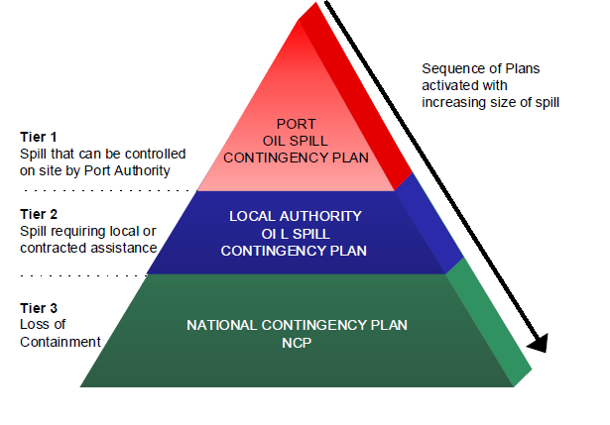

### 4.5 Internal Alerting and Call-out Procedures

An initial spill report will come in the first instance to Forth and Tay Navigation Service (FTNS). The information received must be passed immediately to the Port Manager / Harbour Master / Marine Manager. The Port Manager / Harbour Master / Marine Manager will do their best to confirm the incident details and determine the level of clean-up operation necessary and the requirement as to whether to activate the Port of Dundee operations response team. All calls and decisions made must be recorded and an oil spill report form raised (Section 9). An initial response for Tier 1 incidents will be within 30 minutes.

When the MCA (MRCC Aberdeen) is notified of an incident where there is or may be a risk of significant pollution, they will immediately inform and liaise with the duty Regional Operations Manager, Counter Pollution and Salvage (ROM-CPS) to:

1 evaluate the scale of the incident;

2 decide if the SOSREP should be notified of the incident.

The final decision to notify SOSREP will be the responsibility of the Duty CPSO or HM Coastguard.

### 4.6 Liaison Procedures with Other Agencies

Rapid passing of information to other affected agencies is essential for effective response. Shown below are agencies concerned and their roles followed by an Incident Management Framework for Ports and Harbours extracted from the NCP (September 2014).

**Port of Dundee Limited**

**SEPA**

**Scottish Environment Protection Agency**

* Responsible for water quality in river and estuarine areas
* Waste disposal including oiled clean-up materials regulation
* Regulations for waste disposal, including contaminated clean up material

**DfT**

**Department for Transport**

**MCA / Coastguard**

* Co-ordinate maritime search & rescue
* Primary contact in event of spill
* Classification, categorisation and monitoring
* Establish MRC
* UK Government response
* Authority to co-ordinate response in accordance with the NCP
* Responsible for mobilising government equipment for offshore & onshore clean-up

**Nature Scot**

* Advisors on environmental matters
* Concerned with the conservation of coastal & intertidal habitats and species
* Provide data for scientific assessment of the environment

**Local Authorities (i.e. Dundee City, Fife etc.)**

* Responsibility for shoreline clean-up from HWS to LWS

**Marine Directorate**

* Responsible for the protection of fisheries interests and the marine environment
* Authority for the approval of dispersant use in water depths of <20m or within 1nm of any such area
* Authority to consult with regarding the use of dispersant outwith shallow water areas.

**UKPIA**

**United Kingdom Petroleum Industry**

* Consultation service
* Technical and information services

**LA**

**Cornwall Council**

* Responsibility for shoreline clean-up from HWS to LWS

**HM Revenue & Customs**

* Water Guard Department responsible for claiming Petroleum Revenue Tax from landed recovered oil

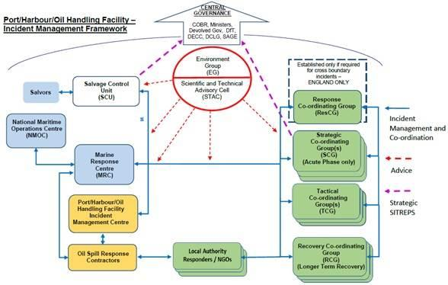

### 4.7 Incidents Involving Mobilisation of Response Cells and SOSREP

#### 4.7.1 The Secretary of State’s Representative

Section 293 of the Merchant Shipping as amended by the Merchant Shipping and Maritime Security Act 1997 gives the Secretary of State powers to intervene in the event of an incident where there is a significant threat of pollution to the UK’s pollution control zone, territorial waters or coastline. This legislation has arisen in the event that a salvage operation for a vessel is required and that the spill must minimise spillage of oil and must not interfere with pollution response operations.

In accordance with the recommendations contained within “Lord Donaldson’s Review of Salvage and Intervention and their Command and Control” a recommendation was made that a single representative should be authorised to act on behalf of the Secretary of State for Trade and Industry. This is the Secretary of State’s Representative (SOSREP).

In the case of ports and harbours the SOSREP’s duties are in respect of salvage only. SOSREP will formally intervene if the salvor does not act in the public interest, tacit approval is assumed if he takes no action. The SOSREP’s role is to represent the over-riding interests of the State and to prevent or reduce pollution. His role does not extend to dealing with the clean-up operation, this responsibility remains with the operator through their own oil spill response arrangements, detailed in the OSCP.

Incidents involving the SOSREP, or his deputy, include incidents involving a vessel where there is, or may be a risk of, significant pollution, or where the Harbour Authority is failing or has failed to implement effective control and preventative operations. This means that the SOSREP, or deputy SOSREP, could be activated even in the event that an incident has not yet occurred but where is there is a risk of such pollution occurring.

The SOSREP could therefore become involved in any of the Tiers of Incident defined in Section 1.

#### 4.7.2 Intervention

Once SOSREP or MCA has decided that it may be necessary to intervene in an incident, he will advise the parties in charge of the casualty, or to whom directions are likely to be given, accordingly. Initial intervention is likely to follow a prior warning to the casualty or her owners that the powers of Intervention may be exercised. This will be accompanied by an offer of help from the MCA and a request for information about the situation and the Master’s intentions.

Initial intervention is likely to be a formal Direction that the owners/salvors plans and intentions are submitted to and approved by SOSREP.

The process of intervening means that the Secretary of State can then issue specific “Directions” to certain specified persons or bodies including:

* Masters
* Owners
* Salvors
* Pilots

Under the Dangerous Vessels legislation, SOSREP could also give directions to a Marine Manager / Harbour Master for the purposes of securing the safety of any person or vessel. This will override directions which may already have been issued by the Harbour Master / Marine Manager to a casualty.

The nature of the directions can be wide ranging provided they are for the purposes of preventing pollution or the risk of pollution and are as respects the ship or its cargo.

#### 4.7.3 Establishment of response cells

During an incident the need to establish response cells to deal with the situation may arise. These may take the form of operational control units or advisory units as the situation requires. The majority of lower level incidents will not require the establishment of response cell, however any event requiring a national response of any kind will require their establishment. Some examples of response cells are listed below and further information on the formation and activities of a response cell can be found in the National Contingency Plan (NCP)

**Salvage Control Unit**

When intervention has been triggered, SOSREP will establish a Salvage Control Unit or SCU. This Unit is led by SOSREP who will oversee, control and if necessary, intervenes in salvage operations where there is a risk of significant pollution. SOSREP works with a team of advisors to encourage salvage contracts and requires that the salvor prepare a salvage plan for agreement by SOSREP prior to any action taking place.

The SCU will be located either adjacent to the Marine Emergency Centre, FTNS Building, Entrance Lock, Grangemouth or at the MRCC Aberdeen.

#### Composition of the Salvage Control Unit

The Salvage Control Unit (SCU) is generally a small group of key people although this list may be expanded as needs dictate:

* SOSREP
* A Salvage Manager representing the on board Salvage Master
* The Harbour Master / Marine Manager if the incident is in or near a harbour or if his harbour is likely to be used as a place of safety to which the casualty may be brought
* An Owner’s Representative
* A CPSO with expertise in pollution cleanup – this person will also liaise with the Maritime and Coastguard Agency’s Marine Response Centre which will be coordinating the at sea cleanup
* An Environmental representative – who will advise SOSREP and form the liaison with the various environmental groups
* A personal Salvage Advisor who SOSREP has engaged.

This team will interact with an on-board team who will normally consist of:

* the Salvors
* SOSREP’s representative and
* in certain cases a Shipowner’s Casualty Representative.

**Marine Response Centre**

The marine Response Centre (MRC) considers and implements the most appropriate means to contain, disperse and remove potential pollutants from the scene based on all the information available to them. In almost all cases involving a national response the MCA establishes a Marine Response Centre at the most appropriate location. The head of CPS Branch determines the need to establish a Marine Response Centre for specific incidents and informs all other cells of its location

**Shoreline Response Centre**

A Shoreline Response Centre (SRC) has a similar function to the marine response centre, the main difference is that it is focused on responding to pollution and response along the shoreline, rather than at sea. Local authorities will be responsible for the establishment of a shoreline response centre.

**Environment Group**

The Environment Group (EG) provides a single advisory line on public health and environmental issues at sea to all response cells. Where the incident poses a significant threat to health or the environment on land the SCG may establish a Science and Technical Advice Cell (STAC) and this may be integrated with with the environment Group. At the outset of an incident at sea, the MCA triggers the formation of an Environment Group to provide advice required by a regional or national response. Standing environmental groups cover the entire UK coastline and MCA co-ordinates the geographical coverage of individual Standing Environment Groups**,** their contact details and call out arrangements. The Environmental Groups comprise the statutory environmental regulators, fisheries departments, nature conservation bodies and public health bodies plus a range of specialist public sector and non-government organisations.

The Environment Group framework enables a co-ordinated and timely environmental input to any other more localised or specialised incidents. The group may be set up as a precautionary approach when the escalation of an incident is a likely possibility. In many minor incidents the operational Environment Group remains a “virtual” group responding with advice when requested.

The environment groups remit is advisory and it has no powers of direction or enforcement. Regulatory functions of individual members of the group are exercised outside the group structure and function.

#### 4.7.4 Places of Refuge

Places of Refuge (PoR) are locations into which a ship which is in need of assistance can be brought, so that its condition can be stabilised and consequential pollution damage to the seas and coasts be averted.

In the UK, the Marine Safety Act 2003 provides powers of intervention and direction to the Secretary of State’s Representative for Maritime Salvage and Intervention (SOSREP), working with the MCA's Counter Pollution and Response Branch.

SOSREP oversees all incidents in UK waters where there is significant risk of pollution, and he or the MCA directs vessels to places of refuge when he judges it appropriate. When a ship in need of assistance requires a PoR, the SOSREP will take account of all the factors which relate to the specific incident, such as the weather, the geographical whereabouts of the incident and the type of threat posed by the vessel and its cargo, with a view to determining the most appropriate place of refuge, minimising adverse consequences.

Refer to The National Contingency Plan for further details on places of refuge.

## Section 5: Response Strategies

### 5.1 Spill Assessment

Spill Assessment Guidelines and Incident Evaluation Guidelines

#### 5.1.1 Introduction

Once an oil spill has occurred it is extremely important to obtain the most accurate information on spill size and type, location and environmental factors. Without this information the rest of the oil spill response cannot be undertaken

#### 5.1.2 Initial Evaluation Checkpoints

A spill assessment and incident evaluation checklist is given overleaf. The following should be borne in mind:

1. The spill assessment and initial incident evaluation should be initiated by the On-Scene Responder.
2. Information should be relayed to FTNS/MEC as quickly as possible.
3. The spill tracking and evaluation should initially be carried out using the duty vessels.
4. For large spills this tracking should be backed up by aircraft over flights once an appropriate aircraft has been mobilised.

*Bear in mind the following when undertaking surveillance/responding to pollution reports:*

1. It is difficult to distinguish the oil from a variety of other unrelated phenomena. These include cloud shadows, ripples on the sea surface and differences in colour of two adjacent water masses.
2. The appearance of tank washings and bilge discharges as a single elongated slick usually distinguishes them from accidental spills.
3. Crude oil will change in appearance soon after spill; in initial stages, the thicker parts will appear as dense, black areas, but as emulsification takes place, the colour will change to brown, orange or yellow.
4. When tracking a slick bear in mind that the thickness will vary, with the thickest portions at the leading edge

Spill Assessment Checklist

|  |  |
| --- | --- |
| STEP | CHECKPOINTS |
| Determine Source of Spill | * If unknown attempt to trace the source of pollution using colour as a guide (increased thickness towards source) |
| Assess Safety Hazard | * Determine safety hazard to personnel and potential hazards to response personnel. * Is there potential for fire or explosion? |
| Establish Tier of Spill | * Tier 1/2/3? * Is spill on going or a one off event? |
| Estimate Approx. Spill Size and Thickness | If the quantity of oil is not known, determine the dimensions of the slick on the water surface and the volume of spilt oil. Conduct by direct observation from duty vessel.  A guide to the relationship between appearance, thickness and volume is provided below. |
| Assess Prevailing Weather & Sea state Conditions | * Wind speed and direction * State of tide and current speed * Wave height |
| Determine Direction & Speed of Oil Movement | * Verify with spill surveillance using tug / aircraft for large spills of crude oil * Estimate impact time to beaching. |
| Obtain Sample of the Oil | * A sample of the spilt oil may help to determine the spill source & may be important for post-incident inquiry. * Procedures for sampling spilt oil are provided below. |
| Identify Potential Affected Shorelines | * Identify threat posed to vulnerable resources e.g. saltmarsh, mudflats, wintering bird populations, tourist beaches in Summer – refer to environmental database in Section 8 and Appendices 1 & 2 . * Observe and chart the current position of the slick; likely future movement and spread to next tidal cycle. |

#### 5.1.3 Slick Predictions

Oil spill modelling is carried out to predict likely distance and direction of movement of the slick predict any threatened coastlines, the scale of likely pollution and may also be used to simulate the likely fate and behaviour of the spilt oil.

Modelling may be carried out using the following methods:

*Manual Method of Slick Prediction*

Slick movement may also be predicted by manual vector addition on the surveillance vessel, or in an emergency when access to a computer programme is not feasible. The manual method of prediction of slick movement is based on a simple vector calculation where the vectors of wind speed and tidal current are added together utilising 3% of the wind speed value and 100% of the tidal current speed. It is important to remember that this method can only provide an approximation of slick movement, and in no way should be regarded as a substitute for continuing monitoring actual slick movement throughout the oil spill response or for the more sophisticated slick predictions generated by computer models. However, the method is rapid and can provide a valuable rough guide to possible slick movement, which may assist in the formulation of an appropriate response strategy.

1. Establish the position of the slick.
2. Establish the tidal rate or strength (in knots) and direction (in degrees) for as many hours as is required. This information is available from the port’s hydrographic data as well as from tidal stream atlases, charts and nautical almanacs.
3. Plot the position of the slick on the most appropriate chart.
4. From that position, draw a vector in the direction that the tide is moving. The tidal rate for the first hour in this example has been established as being 1.5 knots (1.5 nautical miles per hour) and the direction is 0200. From the initial slick position, measure 1.5 nautical miles along the tidal vector. This position is where the slick would have travelled to in that first hour if it had been driven by the tide alone.
5. Obtain as accurate an assessment of the wind speed and direction as possible (the vessel on scene may be able to supply this information). If necessary, convert the wind speed into knots. Multiply the wind speed by 0.03 (the slick is affected by 3% of the wind speed). In this example the wind speed was 11.5 knots which when multiplied by 0.03 is 0.35 knots and the direction is 2700 (a westerly wind). Therefore, in one hour the slick would have moved 0.35 nautical miles in the direction of the wind. The above information will allow a wind vector to be drawn.
6. The slick will be driven by both the wind (3%) and the tide (100%) so it is necessary to combine the two vectors. The wind vector (calculated in step 5) should be drawn from the end of the tidal vector (refer to the diagram overleaf).
7. A line drawn from the initial position of the slick to the end of the wind vector is the resultant vector and indicates the direction and the distance of slick travel in that hour.
8. To predict the likely movement of the oil for another hour, the process should be repeated using the resultant position as the start point for drawing subsequent vectors.

Manual Method of Oil Slick Trajectory Predictions



WIND VECTOR

270˚ TRUE

0.35KNOTS(3.5 CABLES)

#### 5.1.4 Oil Quantity Estimation Guide

The quantity of spilt oil may be estimated using the following oil quantity table taken from the Bonn Agreement Pollution Observation Log. This should be used to estimate the quantity of oil spilt if direct information is not available. *Visual inspection can be carried out from the vessel, but best estimates are made during aerial surveillance flights. When using this colour method to estimate spill size, bear in mind that the slick is likely to be patchy and that the entire area of the slick may not be visible. Examples of slick colour are provided in Figure 2.

It is important to determine the size of the spill and to classify it. The best estimate of spill size will come from plant information, for example, the volume of oil in vessel tanks, pumping rate and duration, diesel in transfer hose. If spill size cannot be determined from plant information, an estimate the following procedure has been taken from the Bonn Agreement Oil Appearance Code (BAOAC).

Table 6 details the current Bonn Agreement colours that should be used to quantify the approximate size of any spill and Table 7 provides a conversion chart. Calculation of the volume of oil spilled from the appearance of oil film on water is as follows:

1. Estimate total size of the area as a square or rectangle (in km) i.e. maximum extremities of the slick.
2. Assess the area affected by the slick in km2 calculated as a % of the total area in (1) (refer Figure 1 below).
3. Estimate the area covered by each colour of oil, calculated as a % of the total area affected.
4. Multiply the area covered by each colour by the appropriate figure in the oil quantity table (Table 6).
5. Adding all of the colour figures will give the total quantity of oil in m3 within the slick.

**Table 6 Oil Quantity estimation by Colour (current Bonn Agreement Code of Practice for Estimating Oil Quantities 2002)**

|  |  |  |  |
| --- | --- | --- | --- |
| Code | Description - Appearance | Layer Thickness Interval (µm) | Litres per km2 |
| 1 | Sheen (silvery/grey) | 0.04 to 0.30 | 40 – 300 |
| 2 | Rainbow | 0.30 to 5.0 | 300 – 5000 |
| 3 | Metallic | 5.0 to 50 | 5000 – 50,000 |
| 4 | Discontinuous true oil colour | 50 to 200 | 50,000 – 200,000 |
| 5 | Continuous true oil colour | 200 to More than 200 | >200,000 |

**Table 7 Conversion Factors**

|  |  |  |
| --- | --- | --- |
| 1 tonne* | 7.45 bbls | |
| 1 bbl | 42 gallons | |
| 1 mile | 1,760 yards | |
| 1 sq mile | 3,097,600 sq yards | |
| 1 mile | 1.61 km | |
| 1 sq mile | 2.59 km2 | |
| * 1 tonne calculated at 844 kg/m3 | |

Estimating the area covered needs to take account of the variable cover of oil on the sea surface. The chart shown in Figure 1 below provides a useful guide to estimating coverage:

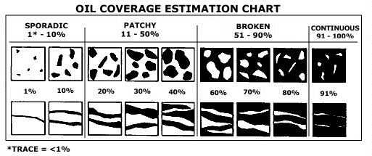Figure 1 Oil Coverage Chart

Figure 2 Examples of Slick Oil Colour from left to right brown crude oil, black heavy fuel oil, rainbow sheen, crude oil water in oil emulsion

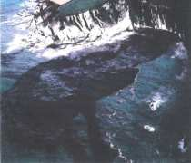



#### 5.1.5 Spilt Oil Sampling

Where an oil pollution incident is thought to be a result of an illegal operational discharge, a sample of the spilt oil should be taken

MCA recommend that 3 samples be collected, the first for analysis to MCA, the second to be provided to the owner or master of the suspect pollution source, and the third for production in court.

Samples should be submitted to the MCA’s contractor laboratory. Once a sample has been taken, agreement must be obtained from the MCA Counter Pollution Branch before it is analysed. Once agreement has been obtained, the Counter Pollution Branch will contact their analysis contractor to arrange for the sample to be collected by courier and analysed.

Samples should be labelled correctly and packed in a suitable container to avoid breakage.

Table 8 Sampling of Spilt Oil

|  |  |  |
| --- | --- | --- |
| No. | Action | Notes |
| 1 | The sample should be taken in a clean glass container as provided in the spill sampling kit. | Metal or plastic containers should be avoided since they may interfere with subsequent fingerprinting |
| 2 | Care should be taken to sample the oil only | The field vessel is provided with dedicated oil sampling kits which include all the equipment necessary for the sampling of spilt oil on the sea surface |
| 3 | Minimum of two samples should be taken. Preferably take three. The following sample sizes provide guidance to what is required for laboratory analyses. | For freshly spilled, relatively non-emulsified oils take at least 30ml to divide between the 3 10ml sample sizes required for lab. analysis;  For emulsions take at least 500ml, to be divided between the three samples required for lab. analysis  If these quantities cannot be obtained a sample should still be taken. |
| 4 | Carefully store samples; these should be sealed to avoid tampering. All samples, once bottled, should be placed in plastic bags and sealed. | Ensure jars are stored in safe place and in a cool dark area away from heat (preferably (<5ºC) |
| 5 | Label or accompanying documentation should contain the following information. | Sample Identification No. and initials of person in charge of sampling Description of samples (eg crude oil, fresh, weathered, water-in-oil emulsion)  Date, time and place of sampling;  Name of Company;  Method of sampling;  Purpose for which sample was taken;  Source if known or suspected;  Metocean conditions at time of sampling  Particulars of any photos or supporting evidence |

##### 5.1.6.1 Identifying Dispersed Oil

Note the following:

1. Some things in and on the water (e.g. suspended solids or algal blooms) can resemble dispersed oil.
2. The appearance of oil slicks and subsurface plumes is affected by factors such as oil characteristics, time of day (different sun angles), weather, sea state, and the rate at which oil disperses.
3. Once dispersant has been applied to a slick, you may observe colour changes in emulsions (mousse), produced as the demulsifying action of the dispersant reduces the water content and viscosity of the emulsion. Demulsification also can produce changes in the shape and size of a slick: as demulsification pushes water out, the slick may appear to shrink in area.

##### 5.1.6.2 Observing When Dispersion Has Occurred

Note the following:

1. A visible subsurface plume of dispersed oil indicates that an application of dispersant is working. When no plume is visible in the water column, it is difficult to determine whether the dispersant is working, but does not definitively mean that the dispersant is not having an effect.
2. Subsurface plumes of dispersed oil typically have a cloudy appearance, and can range in colour from brown to white. Some are not visible. When dispersant is working, oil remaining on the water surface also may change colour.
3. In some cases, you may not be able to see a subsurface plume even when one is present. When the water is turbid, you may not be able to see a plume. Sometimes, remaining surface oil and sheen can mask oil dispersing under the slick, making it hard for you to see the plume.
4. A subsurface plume may not form instantaneously once dispersant has been applied to a slick. In some cases, such as when oil is emulsified, it can take several hours for a plume to form. In other cases, a visible plume may not form (you then may wish to use sampling to learn whether dispersion has occurred).
5. A change in the appearance of a treated slick, compared with an untreated slick, might indicate that the dispersant is working. However, a difference in appearance alone is not enough of an indication to be sure that the dispersant is having an effect.
6. A clear stretch of water left in the wake of a dispersant application vessel can appear to represent successful dispersion of oil. However, areas of clear water can be created as the vessel wave breaks a path through the oil, either physically parting the oil or mechanically dispersing it. Mechanically dispersed oil will coalesce and float to the surface.
7. When initially applied, dispersants sometimes have a herding effect on oil, making a slick appear to be shrinking when, in fact, the dispersant is “pushing” the oil together. This effect results from the surfactant action of dispersants, which exerts a horizontal spreading force on thin oil films. This effect can cause parts of an oil slick to seem to disappear from the sea surface for a short time.

##### 5.1.6.3 Field Testing for Dispersability of Spilt Oil

If the dispersability of the spilt oil is in doubt, or the ability of the dispersant to treat the oil type spilt, run a field dispersability test using dispersants and equipment available on the vessel. Do this as quickly as possible after taking the sample.

Table 9 Field Testing for Dispersability of Spilt Oil

|  |  |
| --- | --- |
| **Water Borne Vessel Mounted Dispersant Spraying Testing** | |
| **Step** | **Action** |
| **1** | Test the amenability of the spilt oil to dispersants following the sampling of the slick. Do this as quickly as possible after taking the sample.  Test carried out as follows: fill a clean screw top jar with seawater; carefully place about 25ml of spilt oil on the surface; add about 1 ml of dispersant (ca. 2 drops) onto the surface. Shake the jar; if the oil does not rise again to the surface but breaks up in the seawater, the slick should be amenable to dispersant spraying. |
| **2** | Undertake calculations to select correct pumping rate and boat speed in relation to nozzle size of equipment. |
| **3** | Initially spray boat should enter the oil on surface at recommended speed to spray at a constant rate and agitate the area. |
| **4** | Watch oil for evidence of dispersion. |
| **5** | As dispersion is achieved it will produce a "smoke plume" in the water. The dispersion will vary in colour between dark and light brown. |
| **6** | If dispersion is not taking place large oil droplets will be evident.  If this is the case STOP spraying. |

#### 5.1.7 Aerial Surveillance

Aerial surveillance is an extremely important part of the marine response to large spills. It should be used for assessing the location and extent of the oil slick, and verifying the predictions of slick movement made as well as progress of natural dispersion and emulsification. It should also be used to direct response operations, be they dispersant spraying, mechanical containment and recovery or, indeed, both.

Aerial surveillance requires specialist aircraft fitted with the following equipment:

* Sideways Looking Airborne Radar (SLAR) for large area, long range detection (20 miles for sea surface and 40 miles for detection on shipping patrol)
* Ultra Violet (UV) sensor for accurate area measurement
* Thermal Infra Red (IR) sensor for relative oil thickness measurement.
* Night Identification System, which enables the name and port of registration of any vessel to be taken in darkness.
* Digital video and still cameras to provide photographic evidence Frequency of Flights

MCA aerial surveillance capability is fitted with these requirements. Mobilisation of this capability will take place at the discretion of MCA in consultation with Forth Ports. Aerial surveillance should be carried out for Tier 2 and 3 spills and should be initiated as quickly as possible.

Following the initial flight, subsequent flights should be made regularly, commonly at the beginning and end of the day so that the results can be used to plan the response operations.

##### 5.1.7.1 Flight Plan

A “ladder search” is the most economical method of surveying a large area of water. Since floating oil has a tendency to become aligned in long and narrow windrows parallel to the direction of the wind, it is advisable to arrange a ladder search across the direction of the prevailing wind to increase the chances of oil detection.

Figure 3 Ladder Search Flight Plan



### 5.2 Health and Safety Guidance

The Health and Safety at Work Act 1974 places a clear duty on all employers and persons responsible for premises to ensure that the workplace is safe and in the case of the employer, to have a safe system of work. This duty is placed regardless of whether the workers are employees, sub-contract workers, temporary workers or self-employed persons.

Implementation of the Health and Safety at Work Regulations 1999 requires that all employers carry out suitable and sufficient Risk Assessments of all tasks to be undertaken in the workplace. Where five or more employees are employed then the Assessment is to be recorded and those at particular risk must be informed accordingly.

These same regulations require that the employer executes a Safety Management System and that measurement of performance against standards is made. All employees must receive adequate training, information and supervision additionally, there is a requirement for all employees to receive suitable and sufficient health surveillance to ensure that they are fit to carry out the work and that the work and conditions do not cause them adverse effect.

The Provision and Use of Work Equipment Regulations 1998 requires that all equipment provided for use at work is safe and fit for purpose. The persons using the equipment must be adequately trained in its use and the operation must be properly supervised.

The Personal Protective Equipment Regulations 1992 requires that all equipment provided is fit for purpose and does not cause adverse effect. That all personnel are trained in its use and that all associated risks are recorded controlled and pointed out to those affected.

The Manual Handling Regulations 1992 requires that all work where lifting, pulling and pushing is involved, is assessed and all risks to the health and safety of those involved are reduced to a level as low as reasonably practicable.

The Control of Substances Hazardous to Health Regulations 2002 requires that all substances to which a worker may be exposed, including dusts and gasses are properly assessed and the risks to health reduced to a safe and acceptable level.

#### 5.2.1 Safety Guidelines for Initial On-Site Assessment

* Before commencing operations ensure safety and health risk evaluations are carried out
* The safety of the general public as well as port employees, visitors and contractors must be taken into account.
* Until it is established otherwise, assume that the spill is giving off lighter fractions that are flammable and explosive
* Always approach the spill from upwind as there may be a vapour cloud
* Close approach to the spill point should not be made unless the area is considered SAFE.
* Eliminate all possible sources of ignition
* Any spill involving confined airspace in which vapours may accumulate should be treated in the initial stages as a potentially explosive situation.
* Until it is established otherwise, assume that the spill is giving off hydrogen sulphide, a highly toxic, colourless gas with an odour of rotten eggs; as even small concentrations cause olfactory fatigue, the sense of smell should not be relied upon to detect this gas.
* If hydrogen sulphide is detected at hazardous levels the area should be evacuated immediately and the on-site response suspended until personnel can be equipped with suitable PPE, or until levels drop to safe and tolerable levels.

#### 5.2.2 Safety Measures for On-Site Response Personnel (including visitors and the general public)

Follow the guidance below:

Bear in mind the following:

* Individuals should not work alone
* If possible a safety boat should be on station for the duration of any boom deployment.
* Personnel should not enter tidal mud flats areas on foot
* No personnel should go below the high water mark unless a “ Safety Officer” is in a secure position to monitor their safety throughout deployment.
* An adequate supply of clean fresh water should be situated at or near the response location(s) for immediate First Aid use.
* Levels of flammable vapours and hydrogen sulphide should be regularly monitored in the early stages of the spill response.
* Access to the site should be controlled.

#### 5.2.3 Personal Protective Equipment

All on-site response personnel should be equipped with appropriate PPE.

For personnel who are likely to handle or come into contact with oil or dispersants the following PPE should be supplied:

* Overalls (preferably disposable)
* Safety helmet
* Safety boots
* Safety glasses
* Gloves (preferably PVC)

Personnel involved in spraying operations should be equipped with:

* Full cover plastic overalls
* Safety helmet
* Face visor (or safety goggles and mouth and nose mask)
* PVC gloves
* Chemical resistant safety boots
* Safety boots
* Lifejacket (if working from a boat or adjacent to water)

#### 5.2.4 Open Water Response Safety Tips

Follow the guidance below:

Open Water Response Safety Tips

* Test for poisonous or explosive gases before approaching spill location
* Lines and chains used for lashing and towing have the potential to cause serious injury and must be checked periodically to avoid accident
* Keep the decks as clean as possible – hazards faced in the open water environment multiply as a result of poor weather, oiled decks and equipment, and congested areas
* Ensure that all responders are familiar with the equipment to be used
* Deck operations carry the risk of falling into the water and drowning so a lifejacket must be worn
* Ensure a tool box talk is conducted before commencing operations
* Secure equipment with tag lines when lifting using deck cranes
* Risk can be minimised by having good communications between the bridge and the deck
* Measures should be taken to ensure vessels and small craft not involved in the response are directed to keep clear.

5.2.5 Dispersant Response Option Safety Tips

Follow the guidance below:

Dispersant Response Operation Safety Tips

* Assess the routes of possible exposure to dispersant chemical
* Provide PPE (see above) to guard against each and every route, ensure all PPE is compatible and fits wearer
* Keep decks clears and dispersant free by regular washing
* Head spray vessels into wind where possible
* Make sure PPE is resistant to dispersant in use
* Avoid uncontrolled release of dispersant
* Avoid unnecessary and prolonged contact with BOTH spilt oils and chemical dispersants
* Always refer to the Material Safety Data Sheets prior to commencing operations
* Ensure that small craft not involved in the response are directed to keep clear of dispersant operations.

#### 5.2.6 Health Effects of Exposure to Spilt Hydrocarbons

Crude oil contains substances that can cause acute as well as chronic health effects. Primary health risks with fresh crude are related to the inhalation of:

SUBSTANCE HEALTH RISK

Hydrogen Sulphide (H2S) toxic

Benzene carcinogen – can cause cancer

Total hydrocarbons irritant, toxic, carcinogenic dependent on crude type

Oxygen displacement asphyxia

In addition prolonged or repeated skin contact may result in dermatitis as well as increased body uptake of some crude oil compounds.

#### First Aid for Contact with or Ingestion of Oils and Dispersants

##### 5.2.7.1 Eyes

For oil or dispersants the eyes should be rinsed thoroughly with copious quantities of fresh clean water for at least for at least 1 –2 minutes. A medical professional should be consulted as soon as possible for advice on further treatment that may be required.

##### 5.2.7.2 Ingestion

Ingestion of oil or dispersant should be initially treated by drinking at least half a pint of milk. Vomiting should not be induced. Professional medical advice should be obtained as soon as possible.

Although dispersants are generally of low toxicity, a copy of the Material Safety Data sheet should if possible be made available to the medics treating the casualty, as this will provide details of any hazardous components and possible harmful effects.

##### 5.2.7.3 Skin Contact

Oil on the skin should be cleaned off with an approved cleanser for this purpose (such as Swarfega), followed by thorough washing with soap and hot water. Solvents or degreasers such as paraffin or white spirit (turpentine substitute) should not be used to remove oil as these may cause industrial dermatitis; on no account should coarse abrasives be used on the skin.

##### 5.2.7.4 General Hygiene

Hands and any exposed skin should be washed thoroughly before eating and after any contact with oils or dispersants. Even if otherwise permitted, smoking should be discouraged when handling dispersants or oil to help avoid any mouth contact. Barrier creams should be used.

Response personnel should not carry oily rags, handkerchiefs or other items that have been heavily oiled in clothing pockets so as to avoid prolonged contact with oil permeating the clothing

Response personnel must not wear clothing which has become heavily soaked with oil or dispersant for extended periods. Such clothing must be exchanged for clean as soon as possible and disposed of as oily waste.

#### 5.2.8 Environment

Refer to the specifications for SSSI and other sensitive areas in appendices 1 and 2.

### Scientific,Technical & Operational Advice Notes

The Maritime and Coastguard Agency publish Scientific, technical and operation (STOp) notes on their website. See link below

<https://www.gov.uk/government/publications/scientific-technical-and-operational-advice-notes-stop-notes>

### Response Procedures

Response procedures and checklists are provided in the following sections for the following:

1. Natural dispersion and monitoring checklist and response procedures;
2. Chemical dispersion checklist and response procedures;
3. Mechanical containment and recovery checklist and procedures;
4. Containing spill in the vicinity of a vessel;
5. Response options for heavy fuel oil spills.
6. Waste Disposal Plan

#### 5.4.1 Natural Dispersion & Response Checklist

| Step | Resources & Actions | Guidance Notes |
| --- | --- | --- |
| Initiate surveillance of spill | * Available vessel * Support Services Unit to mobilise aerial surveillance craft from most appropriate location * For Tier 2/3 request MCA to mobilise aerial surveillance aircraft * Ensure MRCC Aberdeen are aware of intention to track the slick. | * Carry out surveillance from available vessel; follow-up using aircraft surveillance for larger spills (helicopter fights commercially available – refer Section 8 for details) * Floating oil has a tendency to align in long and narrow windrows parallel to the direction of the wind refer Figure 6.3 overleaf). It is advisable to arrange a ladder search across the direction of the prevailing wind to increase chances of oil detection. (see Section 5 Spill Assessment) |
| For larger spills place on standby back-up resources | * Forth Ports Limited dispersant facility * Tier 2 response provider, Ineos Dalmeny & Shell Braefoot | * For any large spill of Group 2 oils or smaller spills of crude oils anti-pollution resources should be placed on standby / mobilised. Refer Section 8 for Equipment Resources |
| Obtain spilt oil sample | * Available vessel should obtain sample. | * Sample may be required for post incident inquiry. Ensure personnel follow procedures given in Section 5. |
| Obtain weather forecasts | * Obtain data from weather forecasting contractor. | * Greater wind speeds and wave conditions will increase speed of natural dispersion. These data will also be important for slick predictions and assessing suitable weather windows for equipment deployment should strategy need to be changed. |
| Slick predictions | * Environmental Unit initiate slick predictions. | * Monitor movement of spill; ensure computer runs are regularly updated. |
| Carry out monitoring | * Resources as mobilised. Ensure that the monitoring covers the points opposite. Table 6.5 provides specifications for aerial surveillance aircraft. Air Reconnaissance contracted to MCA meets these specifications | * Chart slick size, growth patterns; affected area; **feed back data to FTNS/MEC** * Estimate quantities remaining if possible; refer * Identify heaviest concentration of hydrocarbons (these are likely to be at the downwind leading edge of the spill); * Determine proximity of slick to most sensitive areas (refer to Environmental maps & charts in Section 8 and Appendices 1 + 2 ); * Watch for any flocks of birds; * Watch for break up of slick and determine direction of movement of any oil patches; * Report on progress of natural dispersion. |

Figure 4 Distribution of Oil in a Slick

|  |  |
| --- | --- |
| Windrows of Emulsified Oil with Sheen | Windrows of Emulsified Oil |
| oilslick |  |

Ideally for large spills aerial surveillance craft should meet the following specifications:

Table 10 Aerial Surveillance Aircraft Specifications

|  |  |
| --- | --- |
| Equipment | Purpose |
| Infrared Line Scanner imaging equipment | Aids in the assessment of the volume of the spilt oil |
| Suitable navigation equipment including Global Positioning Equipment (GPS) | Ensures the accurate display of search areas and spray patterns and control activities of other resources during counter pollution operations |
| A comprehensive communications suite including multi-channel VHF FM radio, Marine Band (156-174 MHz) | Ensures accurate flow of information to the incident control base |
| Ultra-violet (UV) Liner Scanner imaging equipment | Assesses oil thickness |
| Low light camera equipment with image intensifier and infrared illuminator | Night identification |
| Suitably trained and experienced air crew and other trained staff | To ensure an adequate response capability |

#### 5.4.2 Chemical Dispersion Response Option Checklist

Remember that Marine Directorate must be consulted and their approval obtained prior to dispersant use in any area that does not have a prior derogation to spray unless it is in Zone 6. If spraying is undertaken in Zone 2 ensure that Marine Directorate are informed and consulted.

| Operation | Resources & Actions | Guidance Notes |
| --- | --- | --- |
| Initiate surveillance of spill | * Available vessel * For Tier 2 spills Support Services Unit to mobilise aerial surveillance craft from most appropriate location (refer Section 5 for details of available resources) * MCA will mobilise aerial surveillance aircraft for Tier 3 spills and on request for Tier 2 spills. | * Carry out initial surveillance from available vessel; follow-up using aircraft surveillance. * For aerial surveillance arrange a ladder search across the direction of the prevailing wind to increase the chances of oil detection (refer Section 5) * Ensure MRCC Aberdeen is aware of intention to track the slick. |
| Mobilise dispersant spraying and resources | * Ineos Oil Spill Response equipment, Forth Estuary and Hound Point tugs. Note that dispersant should be used that is amenable to oil type. | * Obtain data on oil type spilt. Request Environment Unit to source dispersant likely to disperse oil type spilt. Note that Dasic Slickgone NS is a wide spectrum dispersant that may disperse a range of oil types. Dasic LTSW also wide spectrum. * Mobilise resources as rapidly as possible in order to maximise effectiveness of response and to prevent beaching. Mobilisation routes provided in Section 8. |
| Obtain spilt oil sample | * Available vessel should obtain sample prior to spraying. | * Sample may be required for post incident inquiry. Ensure personnel follow procedures provided in Section 5. |
| Obtain weather forecasts | * Obtain data from current weather forecasting contractor. | * Important for slick predictions and assessing suitable weather windows for response options and equipment deployment |
| Run slick predictions model | * MEC Operations / Environmental Unit to initiate running of slick predictions. Selected slick predications have been run and recorded for a range of oil spill scenarios in the Firth refer to Section 2. | * Monitor movement of spill; ensure computer runs are regularly updated. |
| Deployment of resources | * Utilise surveillance aircraft to achieve best deployment of resources | * The thickest, downwind sections of the slick should be sprayed first. Use colour guide to identify these or obtain data from surveillance aircraft (refer Section 5). |
| Carry out monitoring | * Utilise resources mobilised for aerial surveillance. | * Utilise aerial surveillance and monitor progress of dispersion. * A minimum of 2 flights a day is recommended. * Refer to Monitoring & Reporting Response Checklist for monitoring. If dispersant spraying is not proving effective : STOP |

#### 5.4.3 Mechanical Containment and Recovery & Coastal Protection Response Checklist

|  |  |  |
| --- | --- | --- |
| Step | Resources and Actions | Guidance Notes |
| Initiate surveillance of spill | * Available vessel * Mobilise aerial surveillance craft from most appropriate location * MCA may mobilise aerial surveillance aircraft * Prior to commencing ensure MCA has been made aware of intention to track slick | * Carry out initial surveillance from vessel; follow-up using aircraft surveillance * Guidelines for vessel surveillance provided in Section 5 * For aerial surveillance arrange a ladder search across the direction of the prevailing wind to increase the chances of oil detection (refer Section 5) |
| Mobilise pollution control resources | * Port Control Resources. | * Refer to Section 5 for mobilisation and equipment resources details |
| Carry out consultations | If required , before deciding upon a coastal strategy for protecting shorelines it is essential to consult with the appropriate local authority whose coast is threatened and appropriate environmental bodies including Nature Scotland, Marine Directorate and SEPA. Note priority protection areas are described in Section 8. | |
| Determine location of sensitive areas | * Refer to Priority Protection Areas map and environmental sensitivity database   Agree on order of priorities for protection | |
| Obtain weather forecasts | * Support Services to obtain data | * Important for assessing suitable weather windows for equipment deployment. Ensure that a record is kept of weather and sea state conditions |
| Deployment of resources | * Oil spill responder to deploy resources * A common difficulty when deploying booms and skimmers to recover oil is controlling the movements and activities of vessels and directing them to the thickest areas of oil. This can be overcome by using aircraft equipped with air to sea communications | * Using results from surveillance to assist in deployment of resources; note that the anti-pollution tug has a side sweep system and can be used on its own or can also deploy additional boom utilising a workboat or other vessel to assist. * Examples of typical booming configurations are provided below. These are examples of how booms can be placed as many booming configurations can be deployed. These configurations will be dependent on metocean conditions, the size and location of the spill at the time of the spill. |
| Carry out monitoring | * Utilise resources as mobilised for aerial surveillance | * Utilise aerial surveillance and monitor progress of response. * Identify heaviest oil concentrations * 2 flights a day should be made. |

Figure 6 Water Borne Containment and Recovery Configurations utilising a single vessel system

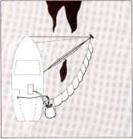

**Single ship recovery system with a boom held in position by a rigid arm and guy ropes. A pocket in the boom contains a skimmer connected to a power pack on deck. Removed oil is pumped into storage tanks on board.**

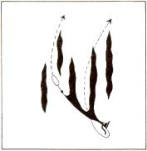

**Single ship system extended with additional vessel towing boom to increase the encounter rate.**

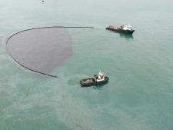

**U configuration towed by two vessels at 1 knot. Oil escaping behind boom is intercepted by a single ship system.**

A range of typical configurations is shown in Figure 7 below. Bear in mind that the appropriate configuration will depend on a range of factors that include:

* The area (size) of the approaching slick
* The amount of redirection necessary
* Wind direction

Figure 7 Potential Boom configurations for diversionary booming

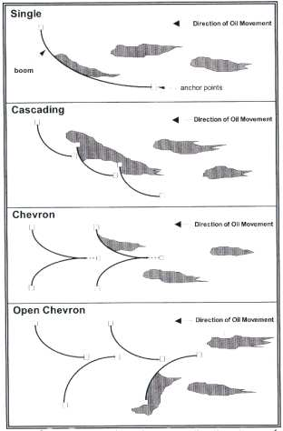

Specific anchor points on the Tay estuary have not been identified. An assessment on the day will be made taking into consideration rate and direction of the tidal flow.

### Disposal Plan

All waste arising from an oil spillage will be handled systematically and strictly in line with the current Regulations. Policy and instructions are identified in Section 1.8. A waste disposal action checklist is shown in Part 2 Section 9.3.

Within the resources of the Plan, initial holding and storage will be possible through use of portable storage tanks as listed in Part 3 Section 11 and thereafter the oil will be disposed of using a local licensed contractor.

In the event of a Tier 2 or 3 spill response, the legal disposal of recovered oil will be undertaken, through a disposal route agreed with SEPA, on behalf of the Port of Dundee. This will be managed by the Port of Dundee nominated Oil Spill Contractor, Adler and Allan, duly accredited to Level 3 under the SEPA / British oil spill control accreditation scheme. Contact details for Adler and Alan can be found in the ‘Emergency Contacts Directory’.

* 1. **Allocation of clean Responsibility**

|  |  |
| --- | --- |
| **Location of Pollution** | **Responsibility for ensuring clean up** |
| On the water, jetties, wharves, structures, beach or shoreline owned by the harbour authority within the port/harbour area | Harbour authority |
| Shoreline (including land exposed by falling tide) | Local Authority |
| Jetties, wharves, structures, beach or shoreline which is privately owned | Owner of the property/ land |
| All other areas at sea (inside the EEZ/ UK pollution control zone and the UK continental shelf | MCA |

# Part 2: Actions & Operations

## Section 6: Action Sheets

### 6.1 Observer of the Incident Report

Observer of the incident calls:

either Port of Dundee

or Forth & Tay Navigation Service

or Police

or Coastguard

or VHF channel 12 – Dundee Harbour Radio

who will obtain fullest details with contact number of the observer if possible and then make contact with:



Call Port of Dundee Port Office/FTNS and ask for Harbour Master / Marine Manager

Mobile phones:

Harbour Master / Marine Manager

Port Manager

or

Direct to Home Numbers

Harbour Master / Marine Manager

Port Manager

**Information to be obtained as Initial Spill Report**

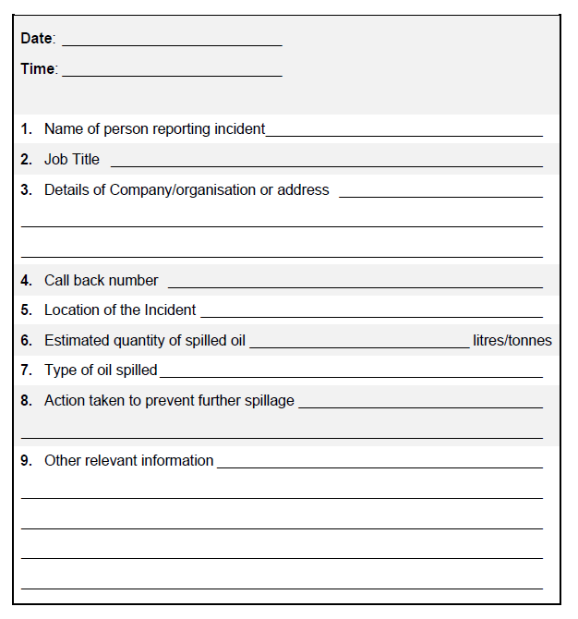

### Harbour Master / Marine Manager - Initial Response Upon Notification of a Spill

### 

Report Spill to MCA

Consult with NatureScot, SEPA and local councils

#### 6.2.1 Harbour Master / Marine Manager - Action Sheet

In the event of a call out requirement, the following action sheets should be used as a check-list to ensure proper cover of all aspects of response.

|  |  |  |
| --- | --- | --- |
| **Harbour Master / Marine Manager** | | |
| **No.** | **ACTION** | **REFER TO** |
| **1.** | Obtain all available information. Ensure that an incident log has been started. | Sect. 9 |
| **2** | Ensure Duty VTSO makes broadcast informing any other vessels in the area of the incident. |  |
| **3.** | Determine initial level of manpower and equipment resource mobilisation required. | Tiered  Response  Sect 1.4 and 11 |
| **4.** | Determine level of response that has been initiated and inform Coastguard, SEPA, MCA and NatureScot of intended response. Inform Local Councils as necessary if oil is spreading out with port limits. Determine level of response required from duty personnel. Inform appropriate local authority Duty Emergency Planning Officer(s) and fully brief them of the incident. | Tiered  Resources  Sect. 1 / Statutory  Notification  Sect 7 |
| **5.** | Contact/Call out Incident Response Team Personnel,. | Mobilisation  Procedure  Sect. 4 |
| **6.** | Ensure that a sample of spilt oil has been taken, especially when the origin of the spill is unknown or legal proceedings are liable to be taken, in conjunction with SEPA. |  |
| **TIER 1 SPILL RESPONSE** | | |
| **No.** | **ACTION** | **REFER TO** |
| **7.** | Call-out additional personnel to handle all additional spill notifications. | Statutory  Notification  Sect. 7 |
| **8.** | Monitor situation. Obtain regular briefings from clean-up  supervisor on progress of clean up. |  |
| **9.** | Determine likely impact of incident. Complete and log a full  report |  |
| **10.** | If it appears that the spill has escalated, proceed as for Tier  2 and Tier 3 incidents. |  |
| **TIER 2 & 3 INCIDENTS** | | |
| **No.** | **ACTION** | **REFER TO** |
| **11.** | Contact response contractor and Local Councils, agree primary level of response required. |  |
| **12.** | Start and maintain an accurate log of all communications with contractor. |  |
| **13.** | Establish communication link with the contractor’s response manager and issue a call back number. |  |
| **14.** | Determine extent of incident in terms of:  • Any casualties;  • Any safety hazard;  • Any impact or likely impact on areas of environmental sensitivities;  • Damage to facilities;  • Extent of pollution;  • Results of any actions taken so far. |  |
| **15.** | Brief Response Supervisor of actions as appropriate. |  |
| **16.** | Establish review/planning meetings. Continue normal communications and ad hoc briefings. |  |
| **17.** | When incident stood down confirm incident closure with all agencies involved. |  |
| **18.** | Complete incident log and ensure receipt of report from response supervisor. |  |

#### 6.2.2 Escalation of Response

In the event that a response escalates to Tier 2 or Tier 3 level, sufficient personnel must be mobilised and room must be made available to meet with personnel from external agencies.

The Harbour Master will retain the position of Incident Controller unless any change is agreed with the Government agencies involved. If the response is likely to become protracted, the MCA will make arrangements for the Marine Response Centre to be managed and run according to the needs of the response team. This may entail providing catering and accommodation arrangements locally.

In the event that outside contractors are employed to assist with the clean-up, Health and Safety Policies must be followed.

### 6.3 Port of Dundee Port Manager

The Port Manager should be ready to assist if deemed necessary by the Harbour Master and must be in a position to make corporate decisions regarding contracts, media reporting and liaising with underwriters.

**PORT OF DUNDEE PORT MANAGER**

|  |  |  |
| --- | --- | --- |
| PORT OF DUNDEE PORT MANAGER | | |
| **No** | **ACTION** | **REFER TO** |
| **1** | Obtain briefing from Harbour Master with situation report and then relocate to Port Office if required. |  |
| **2** | Assess incident in terms of:   * People * Environment * Damage to facilities * Disruption to business |  |
| **3** | Approve outline response strategy | Section 4 |
| **4** | Approve immediate and future contracted equipment requirements. | Section 11 |
| **5** | Arrange initial Public Relations programme. | Section 10 |
| **6** | Attend review meetings in Marine Response Centre. |  |

## Section 7: Communications

### 7.1 Notification Matrix

|  |  |  |  |  |  |
| --- | --- | --- | --- | --- | --- |
|  | **Oil Spill Tier** | | | **For contact numbers see Section 10 Contact Directory** | |
| **Organisation** | **1** | **2** | **3** | **Method** | **Remarks** |
| Port of Dundee Limited Port Manager |  |   🖂 | 🖂 | Telephone, Email |  |
| Port of Dundee Limited Harbour Master |  | 🖂 | 🖂 | Telephone, Email |  |
| MCA  MRCC  Aberdeen |       🖂 |     🖂 |     🖂 | Telephone, Fax, Email |  |
| NatureScot |  |   🖂 |   🖂 | Telephone, Fax, Email |  |
| Dundee City Council  (Angus/Fife/ Perth & Kinross Councils) |    |     🖂 |     🖂 | Telephone,  Fax, Email |  |
| SEPA |     🖂 |   🖂 | 🖂 | Telephone, Email |  |
| Marine Directorate |       🖂 |   🖂 |   🖂 | Telephone, Fax, Email |  |
| Oil Spill  Contractor (A&A) |  |   🖂 |   🖂 | Telephone, Email |  |

|  |  |  |
| --- | --- | --- |
|  Notify immediately by phone   Notify immediately by fax  🖂 Notify immediately by email    Notify during normal working hours |  |  |
|  | |  |

### 7.2 Communications and Reporting

#### 7.2.1 Reporting of Oil Pollution

It is essential that all spills are reported by whatever means as quickly as possible.

* Responsibility for reporting of oil pollution rests with the Master in all cases involving a vessel and with the berth Operator in the case of a berth or quayside incident. In cases involving a vessel alongside both parties are equally responsible.
* Any person either ashore or afloat, seeing oil pollution on the water within the port jurisdiction or liable to pose a threat to it, should report the matter whether or not the source is known.
* The Harbour Master is responsible for ensuring statutory notifications are made.

#### 7.2.2 Communications

Initially reports will be passed by telephone both landline and mobile . The Harbour Authority maintains VHF sets, which would be issued to supervisors once a clean-up strategy had been established.

In the event of a clean-up operation a shift system will be instigated to ensure that all queries are responded to at all times during an incident.

FTNS will be responsible for alerting all vessels in the vicinity. These alerts will be made by VHF and will be made at regular intervals. Relevant vessel agents must also be informed.

#### 7.2.3 Records

It is essential that all events occurring during an incident are logged and recorded (Section 9). This will provide assistance if liability, compensation or reimbursement issues arise as a result of the incident. To achieve this, all key personnel should keep logs.

Entries in the logs should, as a minimum, show details of events, actions taken, communications with outside agencies, decisions made and points relevant to the operation.

These logs should be forwarded to the Dundee Harbour Master once the incident has ended to form part of the final incident report and provide the basis for a “wash-up” meeting.

## Section 8: Sensitive Areas Response Information

### 8.1 Sites of Special Scientific Interest

There are a number of SSSI’s around the River Tay coastline. Details and maps of which can be found in Appendix 1.

### 8.2 Special Areas of Conservation (SAC)

The Port of Dundee falls within the Firth of Tay and Eden Estuary SAC.

The Firth of Tay and Eden Estuary SAC is designated for harbour seal as well as intertidal mudflats and sandflats. Mudflats are particularly sensitive to oil pollution and/or the physical disturbance associated with the clean-up of marine pollution. Further information is available at <https://sitelink.nature.scot/site/8257>

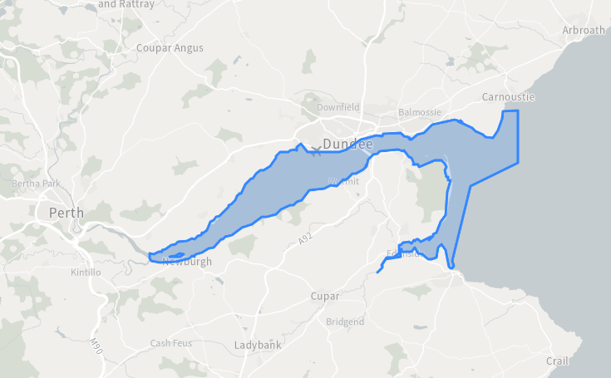

### 8.3 Special Protection Areas (SPAs)

8.31 The Port of Dundee falls within the Firth of Tay and Eden Estuary SPA.

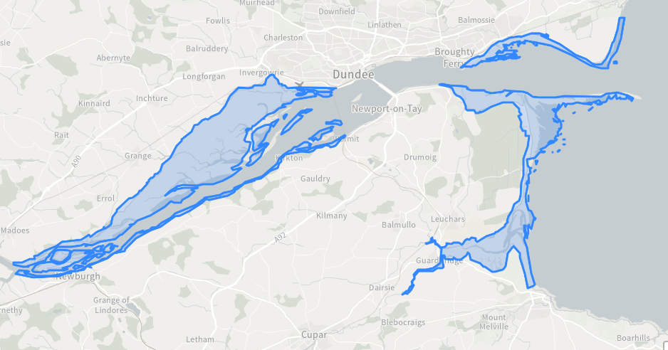

The Firth of Tay and Eden Estuary SPA is protected for a range of wading birds and wintering water birds. Further information is available at <https://sitelink.nature.scot/site/8501>

8.32 The Port of Dundee falls adjacent to the Outer Firth of Forth and St Andrews Bay Complex SPA.

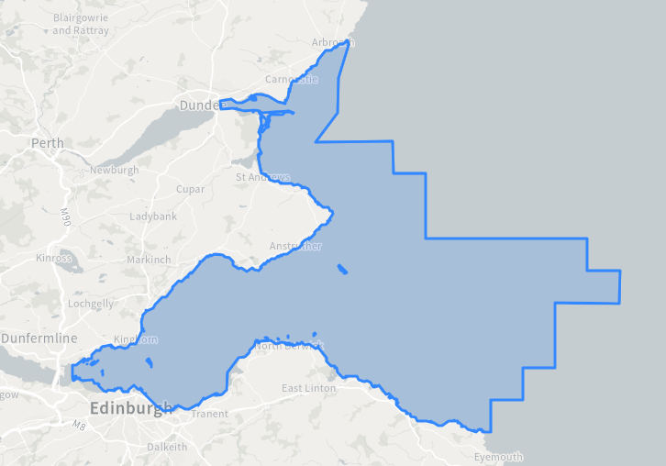

The Outer Firth of Forth and St Andrews Bay Complex SPA is protected for breeding seabirds and wintering waterbirds. Further information is available at <https://sitelink.nature.scot/site/>10478

### 8.4 Fisheries

Diadromous species as salmon (*Salmo salar*), sea trout (*Salmo trutta*) and eels

(*Anguilla anguilla*) have a widespread distribution in the area. These species spend part of their lives in fresh water and part at sea. The salmonoid young, smelt and sparling are spawned in fresh water and then migrate out to sea to mature, while the eels matures in fresh water and reproduces at sea.

The distribution of salmon and sea trout is mainly controlled by natural factors, such as river levels, by man-made barriers that might limit the extent to which they can go upstream and by pollution levels.

The diadromous fishery has a long standing tradition along the river Tay. The most important species are salmon (and grilse, which are salmon that have spent not more than one winter at sea before maturing) and sea trout and the catch of salmon is far more significant than that of sea trout.

### 8.5 Tidal Data

In the section of the River Tay off the Port of Dundee the in-going stream sets across the entrance to Camperdown Dock at less strength than in the centre of the river. The stream is weak or slack from 30 minutes to 40 minutes before HW which presents the best time for entry.

Both the duration and rate of the out-going stream may be increased and the ingoing stream correspondingly reduced, during and after heavy rain or when snow is melting.

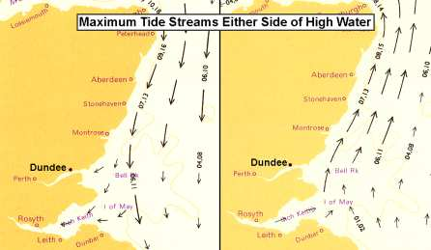

***Flood Tide Ebb Tide***

## Section 9: Report Forms and Checklists

### 9.1 POLREP Pollution Report Form

|  |  |
| --- | --- |
| **Part 1** | **Information which should be provided in an Initial Pollution Report** |
| A | Classification and Category of Report: (1) Doubtful (2) Probable (3) Confirmed |
| B | DATE and TIME pollution observed/reported and identity of observer/reporter |
| C | POSITION and EXTENT of pollution  (If possible, state range and bearing from some prominent landmark or Decca position and estimated amount of pollution, eg, size of polluted area; number of tonnes of oil spilled; or number of containers, drums etc lost. When appropriate, give position of observer relative to pollution) |
| D | TIDE and WIND speed and direction |
| E | WEATHER conditions and SEA state |
| F | CHARACTERISTICS of pollution (Give type of pollution, eg, oil, crude or otherwise; packaged or bulk chemicals; or garbage. For chemicals, give proper name or United Nations Number, if known. For all, give also appearance, eg, liquid; floating solid; liquid oil; semi-liquid sludge; tarry lumps; weathered oil; discolouration of sea; visible vapour; etc). |
| G | SOURCE and CAUSE of pollution if known  (eg, from vessel or other undertaking. If from vessel, say whether as a result of apparent deliberate discharge or a casualty. If the latter, give a brief description. Where possible, give name, type, size, nationality and Port of Registry of polluting vessel. If vessel is proceeding on its way, give course, speed and destination, if known.) |
| H | VESSELS IN THE AREA  (To be given if the polluter cannot be identified and the spill is considered to be of recent origin.) |
| J | Whether PHOTOGRAPHS or SAMPLES have been taken and/or SAMPLES for analysis. |
| K | REMEDIAL ACTION taken, or intended, to deal with the spillage |
| L | FORECAST of likely effect of pollution (eg, arrival on beach, with estimated timing) |
| M | NAMES of those informed other than addresses. |
| N | Any OTHER relevant information (eg, names of other witnesses, references to other instances of pollution pointing to source.) |
| **Part 2** | **Supplementary Information to be provided later.**  (This section may be disregarded when POLREPS are for UK internal distribution only.) |
| O | RESULTS of SAMPLE analysis |
| P | RESULTS of PHOTOGRAPHIC analysis |
| Q | RESULTS of SUPPLEMENTARY ENQUIRIES (eg, inspection by Surveyors, statements from ship’s personnel etc, if applicable) |
| R | RESULTS of MATHEMATICAL MODELS |

|  |  |  |  |  |
| --- | --- | --- | --- | --- |
| **NAME OF PERSON TRANSMITTING REPORT** | | |  | |
| **CONTACT DETAILS** | | **TEL:** | | **FAX:** |
| A |  | | | |
| B |  | | | |
| C |  | | | |
| D |  | | | |
| E |  | | | |
| F |  | | | |
| G |  | | | |
| H |  | | | |
| J |  | | | |
| K |  | | | |
| L |  | | | |
| M |  | | | |
| N |  | | | |
| **Part 2** | **Supplementary Information to be provided later.** | | | |
| O |  | | | |
| P |  | | | |
| Q |  | | | |
| R |  | | | |

When sending follow-up POLREPS ensure that you mark the POLREP follow-up number.

### 9.2 Incident Log Sheet

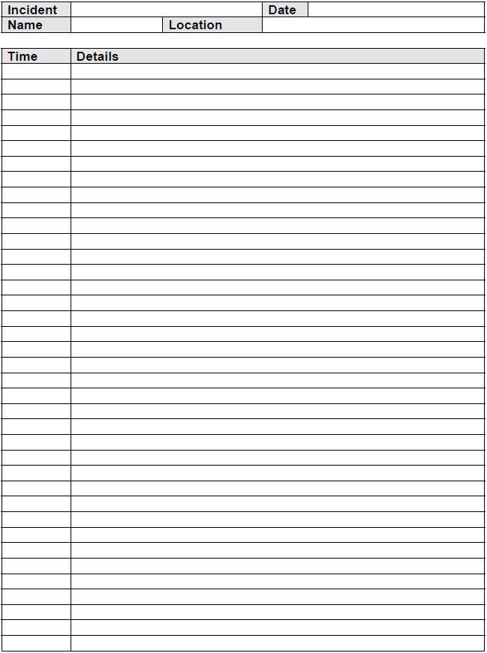

### 9.3 Waste Disposal Action Checklist

#### 9.3.1 Oily waste generated from a shoreline clean-up operation

**a) Temporary storage / clean, treat, stabilise, recover, re-use**

1. Discuss requirement to establish temporary storage sites along the

shoreline with SEPA, the Local Authority and NatureScot, when on or adjacent to an SSSI.

2. If agreed, identify temporary storage sites in close liaison with SEPA and Local Authority.

3. Instruct oil spill response contractors to construct temporary storage sites. Area to be isolated, outlets and drains plugged, membrane laid, bunded area created, skips set or lagoons lined

4. Confirm treatment methods and ultimate disposal with regulator and Local Authority.

5. In close liaison with the oil spill response contractors agree course of action and assist with the necessary arrangements where necessary.

**b) Temporary storage and then to appropriate disposal site for burial**

1. Discuss requirement to establish temporary storage sites along the shoreline with SEPA, NatureScot and the Local Authority.

2. If agreed, identify temporary storage sites in close liaison with SEPA, NatureScot and the Local Authority.

3. Instruct oil spill response contractors to construct temporary storage sites. Area to be isolated, outlets and drains plugged, membrane laid, bunded area created, skips set or lagoons lined

4. Identify suitably licensed waste carrier to remove material from site.

5. Confirm with waste carrier the disposal route and ultimate disposal site.

Liaise with SEPA to ensure that the disposal strategy is acceptable.

6. Ensure all associated paperwork, i.e. consignment notes, are retained and catalogued.

**c) Take to a refinery / incinerator (mainly for oily liquids only)**

1. Identify suitably licensed waste carrier to remove material from site.

2. Identify suitable facility to receive the waste.

3. Confirm with waste carrier the disposal route and ultimate disposal site.

Liaise with SEPA to ensure that the disposal strategy is acceptable.

4. Ensure all associated paperwork, i.e. consignment notes, are retained and catalogued.

**d) Direct transportation to appropriate disposal site for burial**

1. Identify suitably licensed waste carrier to remove material from site

2. Confirm with waste carrier the disposal route and ultimate disposal site.

Liaise with SEPA to ensure that the disposal strategy is acceptable.

3. Ensure all associated paperwork, i.e. consignment notes, are retained and catalogued.

4. Ensure all associated paperwork is retained and catalogued.

#### 9.3.2 Oily liquids recovered at sea and held on a dedicated oil recovery vessel

1. Notify HM Customs and Excise that you intend to land recovered oil.

2. Identify suitable oil handling plant (refinery) to receive the waste.

3. If step 2 is not available identify a harbour with a suitable berth for handling oils.

4. Identify a suitably licensed waste carrier to take the oily liquids off the vessel.

5. Confirm the disposal route with the waste carrier.

6. Notify SEPA and confirm that the identified disposal route meets with their satisfaction. Ensure all associated paperwork, i.e. consignment notes, are retained and catalogued.

## Section 10: Press and Public Information

### 10.1 Media Liaison

In the event of an oil spill that results in media attention The Port of Dundee media consultants (Spreng Thomson) will handle the PR for The Port of Dundee. This company will represent The Port of Dundee to the media. In the event of a Tier 3 incident there will be joint press releases between The Port of Dundee and the MCA PR representatives.

### 10.2 The Media’s Needs

The following summarises the media’s interests in an oil spill event:

* first with news & meet deadlines
* publish details of casualties
* give human interest stories
* present facts including statistics
* bring stories to life with interviews and quotes
* show dramatic pictures
* describe events as they develop
* establish cause
* find new angles different from other coverage

### 10.3 Objectives in Dealing with the Media

The following should be borne in mind:

* To communicate quickly and honestly with all those affected by the emergency to:
* give safety information
* explain how your organisation is responding
* limit adverse comments and damage to reputation
* correct errors in reporting
* promote the positive aspects of your organisation.

It is essential that the media are provided with a “balanced” view of the incident and actions taken. Remarks like “No comment” only increase rumour and fuel unnecessary speculation. Below is the format of an Initial Press Statement that could be used by a responsible Harbour Manager pending full details becoming available and a press release issued.

NB: Unless you are designated as your organisation’s spokesperson you are NOT authorised to offer a comment on behalf of the organisation therefore decline media requests and refer media requests to the Marine Manager.

### 10.4 Sample Press Statements

Sample first public statement for an Oil Spill Incident in The Port of Dundee.

“The Port of Dundee confirm that an incident has occurred (state where and give brief description) …………………. at approximately (give time) ………………….hours today.

Emergency response procedures have been initiated and relevant authorities (have been / are being) advised. All support services are being co-ordinated through the Authority’s incident response team and every possible effort is being made both to minimise risk to personnel at the scene and to contain and mitigate any effects.

Further information will be released, (as it becomes available) at a press conference scheduled for ………….. time today.”

# Part 3: Data Directory

## Section 11: Resources Directory

### 11.1 Tier 1

**Port of Dundee**

This equipment is stored at the tidal basin northwest corner within The Port of Dundee.

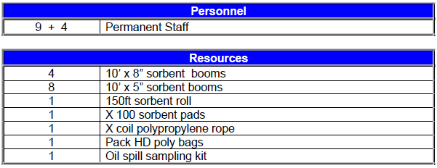

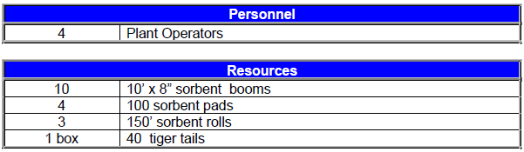 NYNAS UK

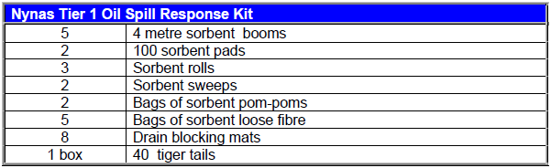Nynas UK currently have an oil spill response trailer that is on ‘standby’ on the quay when crude oil vessels are transferring fuel. The trailer also carries extensive personal protective equipment and other sundry equipment.

### 11.2 Tier 2

Adler and Allan Limited are contracted by Forth Ports Limited to provide Tier 2 response in The Port of Dundee Harbour Area. Individual assets may be held by Adler and Allan Ltd at Montrose and Glasgow that are available on a 24/7 rapid mobilisation basis to meet all contractual obligations.

**8.3 tonnes pre-loaded containment and Recovery**

|  |  |
| --- | --- |
| 8.3 tonnes rigid with tail lift | 1 |
| Inflatable Sea Boom 75i | 200m |
| Rigid Fence Boom 50p | 80m |
| Silverbeach 55 Shore sealing boom | 80m |
| Minimax Weir Skimmer | 1 |
| Spate 75c diesel driven pump | 1 |
| Safety boat, oars, pump and outboard | 1 |
| Generator Honda EC4000B | 1 |
| Lighting set | 1 |
| Fastank On Land Storage | 2000 Gallon |
| Blower Echo PB6000 | 1 |
| Honda WP20X Water Pump | 1 |
| Anchors chains, buoys | 5 sets |
| Rope | 400m |
| Medical Kit | 1 |
| Extinguisher Powder 2Kg | 2 |
| Heavy duty waste bags | 100 |
| Rakes and shovels | 3 of each |
| Towing Bridles | 3 |
| Sand bags | 50 |
| Stakes | 6 |
| Rammer | 1 |
| Sorbents – 3m booms | 4 |
| Sorbents - Roll | 1 |
| Sorbents - sheets | 3 packs |
| PPE safety glasses, gauntlets, overalls | 20 each |
| Notice boards, barrier tape | 2 each |
| Mop | 1 |
| Decontamination tank | 1 |
| Polythene sheeting | Large roll |
| Fuel tanks | 2 |
| Tool kit and spares kit | 1 |

### 11.3 Available Watercraft

**Harbour Craft**

The harbour owns and operates two Pilot Vessels, the Taybird and Forth Tiger. In emergency situations these vessels can be used to assist in spill response. Each craft is equipped with basic oil spill response equipment and vessels Coxswains trained in the deployment of this equipment.

**External Vessels**

The port has a relationship with Targe Towing to provide port towage in Dundee. Targe tugs are based in the Forth and in Aberdeen. No Tugs are permanently based in Dundee.

## Section 12: Product Information Sheets

### 12.1 Product Information Sheets

All products passing through the port of Dundee should be treated individually. For each hydrocarbon cargo a product information sheet will be present and should be referred to for any emergency situation. Product information sheets will be held by the Vessel and also the Terminal.

## Appendix 1– SSSI Citations

**1.1 Inner Tay Estuary**



**CITATION**

**INNER TAY ESTUARY**

**SITE OF SPECIAL SCIENTIFIC INTEREST**

Perth and Kinross, Fife, Dundee City

Site code: 809

NATIONAL GRID REFERENCE: NO 197191 to NO 390292 (north shore)

NO 198185 to NO 395263 (south shore)

NO 224188 (Mugdrum Island)

OS 1:50,000 SHEET NO: Landranger Series 53, 54, 58, 59

1:25,000 SHEET NO: Explorer Series 370, 371, 380

AREA: 4115.38 hectares

**NOTIFIED NATURAL FEATURES**

**Biological: Birds: Greylag goose *Anser anser*, non-breeding**

**Pink-footed goose *Anser brachyrhynchus*, non-breeding**

**Cormorant *Phalacrocorax carbo*, non-breeding**

**Goldeneye *Bucephala clangula*, non-breeding**

**Bearded tit *Panurus biarmicus*, breeding**

**Marsh harrier *Circus aeruginosus*, breeding**

**Water rail *Rallus aquaticus*, breeding**

**Breeding bird assemblage**

**Coastlands: Saltmarsh**

**Fens: Transition saltmarsh**

**DESCRIPTION**

The Tay Estuary is one of the largest estuaries in Scotland. It stretches for approximately 20km from the confluence of the Rivers Earn and Tay in the west to the Tay rail bridge in the east, and is 2.5km at its widest. The site consists primarily of inter-tidal sand and mud flats that extend seawards out to the main channel, the majority of which lie on the northern side of the estuary. The site is important for its wintering populations of roosting grey geese, its breeding birds, including several nationally important populations, its saltmarsh habitats, and habitats demonstrating the transition from saltmarsh to freshwater fens and dry land.

The mudflats, sandbanks and Mugdrum Island offer safe roosting places for nationally important numbers of wintering geese (greylag goose *Anser anser* and pink-footed goose *Anser brachyrhynchus*), whose numbers are at their highest during autumn and spring passage. The site holds nationally important numbers of goldeneye *Bucephala clangula* and cormorant *Phalacrocorax carbo* which feed over the inter-tidal sandbanks and mudflats at high tide; cormorants also roost on the sand bars at low water. Although not part of the notified interest, the estuary also supports large populations of migratory and wintering waders such as dunlin *Calidris alpina*, bar-tailed godwit *Limosa lapponica* and redshank *Tringa totanus*.

The estuary is notable for its extensive areas of reedbed and saltmarsh habitats. At the seaward end of the site there are areas of estuarine saltmarsh of which there are relatively few extensive examples on the east coast of Scotland. A number of locally rare saltmarsh plants occur including sea club-rush *Bolboschoenus maritimus,* grey bulrush *Schoenoplectus tabernaemontani* and common saltmarsh grass *Puccinellia maritima*.

The *Phragmites* reedbeds are the main transitional saltmarsh habitats. The reedbed on the north shore of the estuary is thought to be the largest continuous stand of this species in Britain. The reedbeds are unusual because they are flooded at spring tides; in the inner estuary the tide is usually fresh water, but becomes increasing brackish downstream. A number of locally rare plants occur in the reedbeds such as whorl grass *Catabrosa aquatica.*

The reedbeds also provide nesting habitat for nationally important populations of bearded tit, marsh harrier and water rail which, in combination with species like reed bunting, reed warbler and sedge warbler, form part of the breeding bird assemblage for the site.

Although not a part of the notified interest, due to their size and northerly estuarine situation, the reedbeds and wetlands also support a rich assemblage of insects, some of which are unknown elsewhere in Scotland. The abundance of insect life also attracts large numbers of swallows and sand martins on their autumn passage.

**NOTIFICATION HISTORY**

First notified under the National Parks and Access to the Countryside Act 1949:

1955 (as Mugdrum Island SSSI),

1972 (as Tay Estuary and Mugdrum Island SSSI),

1973 (as Tay Estuary SSSI).

Notified under the Wildlife and Countryside Act 1981: 23 August 1985 (as Inner Tay Estuary SSSI) with a 1143 ha increase in area.

Re-notified under the 1981 Act: 25 August 1999 with a 1348 ha increase in area.

Notification reviewed under the Nature Conservation (Scotland) Act 2004:

10 September 2010.

**REMARKS**

Measured area of site corrected (from 6748 ha) to exclude area below MLWS.

Part of Inner Tay Estuary SSSI overlaps with part of Balmerino - Wormit Shore SSSI which is notified for old red sandstone igneous geology.

Inner Tay Estuary SSSI is contiguous to Flisk Wood SSSI.

Inner Tay Estuary SSSI is part of the Firth of Tay and Eden Estuary Special Area of Conservation (SAC) which is designated for the European habitats and species listed below:

Habitats: Estuaries: Intertidal mudflats and sandflats

Subtidal sandbanks

Species: Common seal *Phoca vitulina*

Inner Tay Estuary SSSI is part of the Firth of Tay and Eden Estuary Special Protection Area (SPA), which is designated for the birds listed below:

Bar-tailed godwit *Limosa lapponica*, non-breeding

Common scoter *Melanitta nigra*, non-breeding

Cormorant *Phalacrocorax carbo*, non-breeding

Dunlin *Calidris alpina alpina*, non-breeding

Eider *Somateria mollissima*, non-breeding

Goldeneye *Bucephala clangula*, non-breeding

Goosander *Mergus merganser*, non-breeding

Grey plover *Pluvialis squatarola*, non-breeding

Greylag goose *Anser anser*, non-breeding

Icelandic Black-tailed Godwit *Limosa limosa islandica*, non-breeding

Little tern *Sterna albifrons*, breeding

Long-tailed duck *Clangula hyemalis*, non-breeding

Marsh harrier *Circus aeruginosus*, breeding

Oystercatcher *Haematopus ostralegus*, non-breeding

Pink-footed goose *Anser brachyrhynchus*, non-breeding

Red-breasted merganser *Mergus serrator*, non-breeding

Redshank *Tringa totanus*, non-breeding

Sanderling *Calidris alba*, non-breeding

Shelduck *Tadorna tadorna*, non-breeding

Velvet scoter *Melanitta fusca*, non-breeding

Waterfowl assemblage, non-breeding

**1.2 Balmerino – Wormit Shore**

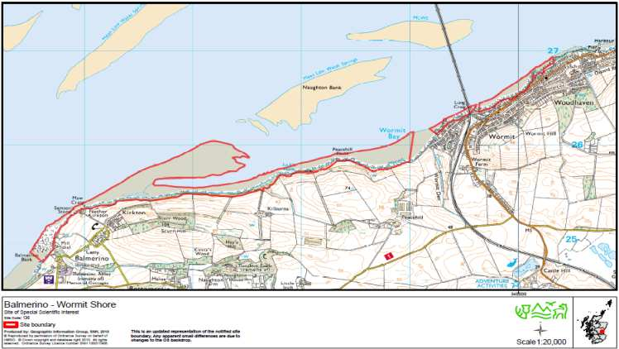

**CITATION BALMERINO – WORMIT SHORE**

**SITE OF SPECIAL SCIENTIFIC INTEREST**

Fife Site Code: 136

NATIONAL GRID REFERENCE: NO 380257 (NO 356249 – NO 402268)

OS 1:50,000 SHEET NO: Landranger Series 59

1:25,000 SHEET NO: Explorer Series 371

AREA: 84.52 ha.

NOTIFIED NATURAL FEATURES

Geological Igneous Petrology: Old Red Sandstone Igneous

The Balmerino to Wormit shore SSSI, on the south bank of the Firth of Tay between Balmerino and Wormit, provides the most completely exposed section in Fife through the Lower Devonian lavas and associated sedimentary rocks of Fife.

These rocks are part of the same group of volcanic rocks that make up the Ochil Hills, and were formed about 410 million years ago, the lavas being erupted from fissures onto low ground or into lakes and rivers. A range of lava compositions is present including basalt, basic pyroxene andesite and andesite. The lavas are often notably feldsparphyric and in places pillow and peperite (thermally shattered magma) structures indicate an aqueous environment of extrusion or shallow intrusion. A fine sequence of volcaniclastic deposits is exposed along Wormit shore and includes tuffs and mixed acid and basic agglomerates.

The site is of international importance for the information it gives about the geography of southern Scotland at that time, and nationally important in deciphering the nature and environment of volcanic activity during the Lower Devonian in Fife.

**NOTIFICATION HISTORY**

First notified under the 1949 Act: November 1971

Re-notified under the 1981 Act: 31 July 1989

Notification reviewed under 2004 Act: 24 April 2008.

**REMARKS**

Measured area of site corrected (from 85.2 hectares).

A composite site in three parts.

**1.3 Tayport – Tentsmuir Coast**

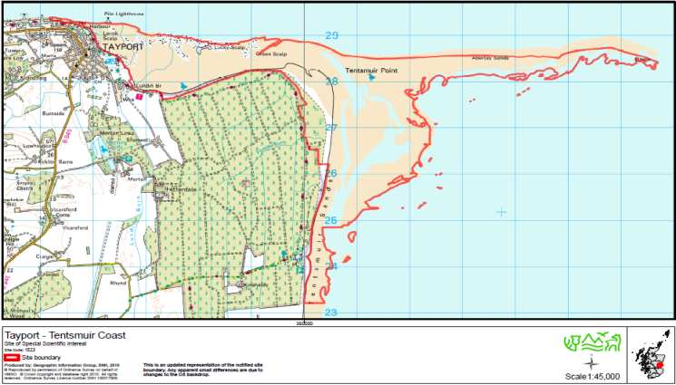

**CITATION**

**TAYPORT – TENTSMUIR COAST**

SITE OF SPECIAL SCIENTIFIC INTEREST

Fife

Site code: 1523

NATIONAL GRID REFERENCE: NO 452293 to NO 502232

OS 1:50,000 SHEET NO: Landranger Series 59

1:25,000 SHEET NO: Explorer Series 371

AREA: 1261.29 hectares

**NOTIFIED NATURAL FEATURES**

Geological

**Geomorphology: Coastal Geomorphology of Scotland**

Biological

Coastlands: Mudflat

Sand dune

Vascular plants: Vascular plant assemblage

Birds: Bar-tailed godwit (*Limosa lapponica*), non-breeding

Common scoter (*Melanitta nigra*), non-breeding

Eider(*Somateria mollissima*), non-breeding

Goosander (*Mergus merganser*), non-breeding

Long-tailed duck (*Clangula hyemalis*), non-breeding

Pink-footed goose (*Anser brachyrhynchus*), non-breeding

Red-breasted merganser (*Mergus serrator*), non-breeding

Mammals: Common seal (*Phoca vitulina*)

Invertebrates: Beetle assemblage

**DESCRIPTION**

Tayport - Tentsmuir Coast Site of Special Scientific Interest (SSSI) is situated in the extreme north-east corner of Fife, and comprises a coastal strip extending from Tayport to Kinshaldy, approximately 10 km due north of St Andrews.

This is a key geomorphological site for the study of active beach and coastal processes, in particular those associated with coastal progradation (shoreline advance). It is exceptional in Scotland for the rate and amount of coastal accretion (sediment accumulation) since the time of the post-glacial sea-level high. This accretion is actively continuing and is due to the massive sediment load carried to the sea by the River Tay and built into extensive bar and spit systems. The interest of the site is significantly enhanced by the juxtaposition of three distinctive coastal environments: that of the north coast dominated by the dynamic processes of the Tay estuary; that of the Abertay sand bars and shoal banks which play a fundamental role in the coastal accretion; and that of the coast to the south where open coast processes become progressively more dominant. The site has considerable potential for studies of the processes and development of coastal progradation and also of the interaction of vegetation with accretionary processes and landforms.

The site exhibits an extensive and relatively undisturbed area of intertidal sand and mudflats with some of the most extensive eelgrass *Zostera* spp beds in the Tay estuary. Three nationally scarce species of *Zostera* are present. These intertidal habitats show transitional developments into salt marsh communities, occurring both as distinct habitat units and smaller fragments dominated by common saltmarsh grass *Puccinellia maritima* and sea club-rush *Bolboschoenus maritimus,* grading into landward areas of saltmarsh rush *Juncus gerardii*. Rapidly accreting sand dunes continue the landward development and are predominantly lime-poor, but calcareous and more neutral dune substrates also exist. The dune system exhibits a complete sequence of dune and slack successional development from strandline, dominated by common couch-grass *Elytrigia repens*, through foredunes and yellow dunes with sand couch-grass *Elytrigia juncea*, marram grass *Ammophila arenaria* and lyme grass *Leymus arenarius*, to grey dunes, slacks and dune heath with scrub and deciduous woodland. Species here range from moss and lichen communities through richer areas with creeping willow *Salix repens*, coralroot orchid *Corallorhiza trifida* and seaside centaury *Centaurium littorale* to more acid situations with heather *Calluna vulgaris*, crowberry *Empetrum nigrum*, grey willow *Salix cinerea* and silver birch *Betula pendula*.

This diversity of habitats supports over 320 higher plant species and over 160 fungi, lichens, mosses and liverworts, several of which are recorded as nationally and regionally scarce, such as seaside centaury and coral root orchid together with Baltic rush *Juncus balticus* and dense-flowered fumitory *Fumaria densiflora*. Several of these species are distinctly “northern” and occur here at or near their southern limit in eastern Britain, contrasting markedly with the predominantly “southern” flora on sand dunes elsewhere in Fife. In contrast, species like the broad-leaved helleborine *Epipactis helleborine*, fern-grass *Catapodium rigidum* and sea-purslane *Atriplex portulacoides* occur here at their most extreme northern location.

The intertidal flats regularly support a large assemblage of wintering waterfowl including nationally important passage or wintering populations of pink-footed goose, eider, long-tailed duck, common scoter, red-breasted merganser, goosander and bar-tailed godwit in numbers in excess of 1% of their British populations. The site is particularly important for wintering eider, with peak numbers exceeding 8,300, some 11.45% of the British wintering population.

The outer sandflats provide for a nationally important pupping and moulting haul-out for approximately 150 common seals. Grey seals also use the area as a summer haul-out, in numbers averaging around 1,000, but not for breeding or moulting.

There are 30 rare or notable species of beetle found at Tayport–Tentsmuir Coast including *Leiodes ciliaris* and *Orthocerus clavicornis* as well as locally important species such as *Aegialia arenaria* and *Anomala dubia*, all of which contribute to an outstanding assemblage of invertebrates associated with sand dune systems including heath, scrub and pine. The sand dune invertebrate fauna is particularly rich and diverse, including 46 nationally rare or scarce species. Four of these are Red Data Book species, including the cousin German moth *Protolampra sobrina*.

NOTIFICATION HISTORY

Part notified under the 1949 Act: 1954 and 1962 as Tentsmuir Point NNR

Re-notified under the 1981 Act: 21 February 1984 as Tayport – Tentsmuir Coast SSSI with a 538 ha increase in area.

Re-notified under the 1981 Act: 1 February 1993 with a 4.8 ha increase in area.

Re-notified under the 1981 Act: 25 September 1999 with a 153.8 ha increase in area.

Notification reviewed under the 2004 Act: 13 October 2010

**REMARKS**

Measured area of site corrected (from 1202.11 ha).

Tayport – Tentsmuir Coast SSSI is part of Firth of Tay and Eden Estuary Special Area of Conservation (SAC) designated for the European habitats and species listed below and is part of Firth of Tay and Eden Estuary Special Protection Area (SPA) designated for the birds listed below.

Habitats: Estuaries

Intertidal mudflats and sandflats

Subtidal sandbanks

Species: Common seal (*Phoca vitulina*)

Birds: Bar-tailed godwit (*Limosa lapponica*), non-breeding

Common scoter (*Melanitta nigra*), non-breeding

Cormorant (*Phalacrocorax carbo*), non-breeding

Dunlin (*Calidris alpina alpina*), non-breeding

Eider (*Somateria mollissima*), non-breeding

Goldeneye (*Bucephala clangula*), non-breeding

Goosander (*Mergus merganser*), non-breeding

Grey plover (*Pluvialis squatarola*), non-breeding

Greylag goose (*Anser anser*), non-breeding

Icelandic Black tailed godwit (*Limosa limosa islandica*), non-breeding

Little tern (*Sternula albifrons*), breeding

Long-tailed duck (*Clangula hyemalis*), non-breeding

Marsh harrier (*Circus aeruginosus*), breeding

Oystercatcher (*Haematopus ostralegus*), non-breeding

Pink-footed goose (*Anser brachyrhynchus*), non-breeding

Red-breasted merganser (*Mergus serrator*), non-breeding

Redshank (*Tringa totanus*), non-breeding

Sanderling (*Calidris alba*), non-breeding

Shelduck (*Tadorna tadorna*), non-breeding

Velvet scoter (*Melanitta fusca*), non-breeding

Waterfowl assemblage, non-breeding

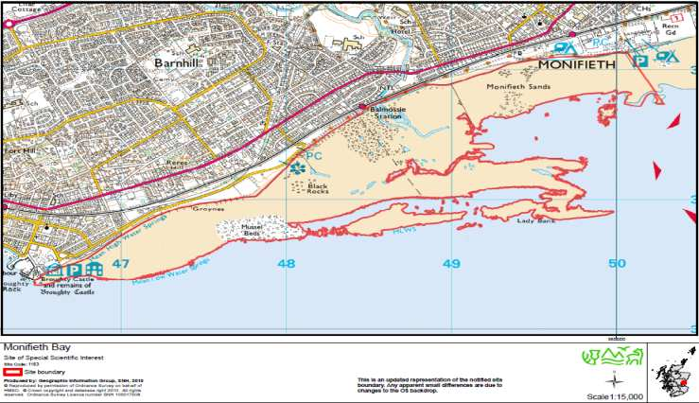**1.4 Monifieth Bay**

**CITATION MONIFIETH BAY**

**SITE OF SPECIAL SCIENTIFIC INTEREST**

Dundee City, Angus Site code: 1183

NATIONAL GRID REFERENCE: NO 485313

OS 1:50,000 SHEET NO: Landranger Series 54

1:25,000 SHEET NO: Explorer Series 380

AREA: 199.23 hectares

**NOTIFIED NATURAL FEATURES**

**Biological: Birds: Sanderling *Calidris alba*, non-breeding**

**DESCRIPTION**:

Monifieth Bay is situated on the north shore of the outer Firth of Tay 5 km east of Dundee. It consists primarily of intertidal sand and mud, extending for four km along the coast and up to 1km seawards. The site is important as the extensive mud flats with its rich invertebrate population provide a feeding ground for wintering waders specifically important numbers of sanderling.

Sanderling utilise Monifieth Bay at low tide to feed on the exposed mud and sand. They roost elsewhere, mainly on Buddon Ness to the east and on Lucky Scalp on the south side of the estuary.

**NOTIFICATION HISTORY**

First notified under the Wildlife and Countryside Act 1981: 30 January 1984

Notified under the Wildlife and Countryside Act 1981: 09 May 1985

Notification reviewed under the Nature Conservation (Scotland) Act 2004:

21 May 2010

**REMARKS**

Measured area of site corrected (from 212.7 ha)

Monifieth Bay SSSI is also a constituent part of the Firth of Tay and Eden Estuary Special Protection Area (SPA) which is designated for the birds listed below:

Bar-tailed godwit *Limosa lapponica*, non-breeding

Common scoter *Melanitta nigra*, non-breeding

Cormorant *Phalacrocorax carbo*, non-breeding

|  |
| --- |
| Dunlin *Calidris alpina alpina*, non-breeding |
| Eider *Somateria mollissima*, non-breeding |
| Goldeneye *Bucephala clangula*, non-breeding |
| Goosander *Mergus merganser*, non-breeding |
| Grey plover *Pluvialis squatarola*, non-breeding |
| Greylag goose *Anser anser*, non-breeding |
| Icelandic Black-tailed godwit *Limosa limosa islandica*, non-breeding |
| Little tern *Sterna albifrons*, breeding |
| Long-tailed duck *Clangula hyemalis*, non-breeding |
| Marsh harrier *Circus aeruginosus*, breeding |
| Oystercatcher *Haematopus ostralegus*, non-breeding |
| Pink-footed goose *Anser brachyrhynchus*, non-breeding |
| Red-breasted merganser *Mergus serrator*, non-breeding |
| Redshank *Tringa totanus*, non-breeding |
| Sanderling *Calidris alba*, non-breeding |
| Shelduck *Tadorna tadorna*, non-breeding |
| Velvet scoter *Melanitta fusca*, non-breeding |
| Waterfowl assemblage, non-breeding |

Monifieth Bay SSSI is also a constituent part of the Firth of Tay and Eden Estuary Special Area of Conservation (SAC) which is designated for the European habitats and species listed below:

Habitates: Estuaries

Intertidal mudflats and sandflats

Subtidal sandbanks

Species: Common seal *Phoca vitulina*

**1.5 Barry Links**

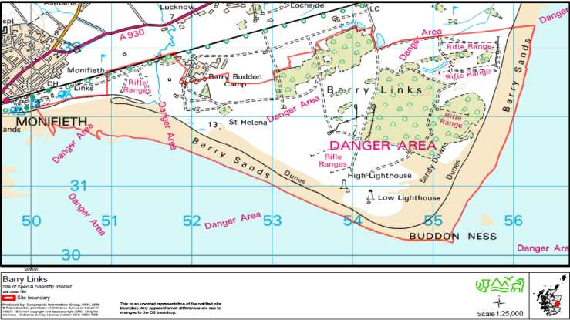

CITATION

**BARRY LINKS**

**SITE OF SPECIAL SCIENTIFIC INTEREST**

Angus

Site code: 154

NATIONAL GRID REFERENCE: NO 540319

OS 1:50,000 SHEET NO: Landranger Series: 54

1:25,000 SHEET NO: Explorer Series: 382

AREA: 1027.51 ha

**NOTIFIED NATURAL FEATURES**

**Geological: Geomorphology: Coastal geomorphology of Scotland**

**Biological: Coastlands: Sand dunes**

**Non-vascular plants: Bryophyte assemblage**

**Invertebrates: Invertebrate assemblage**

**DESCRIPTION**:

Barry Links lies on the northern side of the mouth of the Firth of Tay to the east of Monifieth. The sand dune system is one of the largest on the east coast of Scotland and forms a peninsula jutting out into the estuary. It is a complex site which provides a valuable example of an active dune system and a full range of dune habitats which support a wide range of plants, mosses, liverworts, and invertebrates.

The extensive sand-covered foreland of Barry Links provides a representative assemblage of many beach, dune and links landforms that offer valuable opportunities for studies of coastal evolution. The site is particularly noted for its parabolic dune system, one of the finest of this type in Britain, comprising unique, elongated ‘hairpin’ landforms with an exceptionally regular and repeated pattern. These unique characteristics may reflect the unusually open exposure of the foreland and the lack of topographic interference with formative winds. Barry Links is therefore a key site for coastal geomorphology.

The peninsula consists of blown-sand showing all of the classic elements of coastal dune succession, with the full range of characteristic plant communities. These communities are relatively undisturbed, and support a large number of vascular plant species. In the damp dune slacks the site has also supported a number of rare mosses and liverworts including Warne's thread-moss *Bryum warneum*. There is an extensive range of invertebrates including beetles, moths and butterflies, flies and spiders; they include notable species such as the shore spider *Dictyna major*, the stiletto fly *Dialineura anilis*, and the small blue butterfly *Cupido minimus*.

**NOTIFICATION HISTORY**

First notified under the National Parks and Access to the Countryside Act 1949:

1961 and 1974

Re-notified under the Wildlife and Countryside Act 1981: 30 January 1984 and,

9 May 1985, with a 32.6 hectare increase in area.

Notification reviewed under the Nature Conservation (Scotland) Act 2004:

5 November 2010

**REMARKS**

Measured area of site corrected (from 1,041.1 ha).

Part of Barry Links SSSI forms the Barry Links Special Area of Conservation (SAC) which is designated for the European habitats listed below:

Habitats: Coastal dune heathland

Dune grassland

Humid dune slacks

Shifting dunes

Shifting dunes with marram

The remainder of Barry Links SSSI is part of Firth of Tay and Eden Estuary Special Area of Conservation (SAC) which is designated for the European habitats and species listed below:

Habitats: Estuaries

Intertidal mudflats and sandflats

Subtidal sandbanks

Species: Common seal *Phoca vitulina*

Part of Barry Links SSSI is part of Firth of Tay and Eden Estuary Special Protection Area (SPA) for the birds listed below:

Bar-tailed godwit *Limosa lapponica*, non-breeding

Common scoter *Melanitta nigra*, non-breeding

Cormorant *Phalacrocorax carbo*, non-breeding

Dunlin *Calidris alpina alpina*, non-breeding

Eider *Somateria mollissima*, non-breeding

Goldeneye *Bucephala clangula*, non-breeding

Goosander *Mergus merganser*, non-breeding

Grey plover *Pluvialis squatarola*, non-breeding

Greylag goose *Anser anser*, non-breeding

Icelandic Black-tailed Godwit *Limosa limosa islandica*, non-breeding

Little tern *Sterna albifrons*, breeding

Long-tailed duck *Clangula hyemalis*, non-breeding

Marsh harrier *Circus aeruginosus*, breeding

Oystercatcher *Haematopus ostralegus*, non-breeding

Pink-footed goose *Anser brachyrhynchus*, non-breeding

Red-breasted merganser *Mergus serrator*, non-breeding

Redshank *Tringa totanus*, non-breeding

Sanderling *Calidris alba*, non-breeding

Shelduck *Tadorna tadorna*, non-breeding

Velvet scoter *Melanitta fusca*, non-breeding

Waterfowl assemblage, non-breeding

## Appendix 2- Overview of Designations

**Land Based Designations**

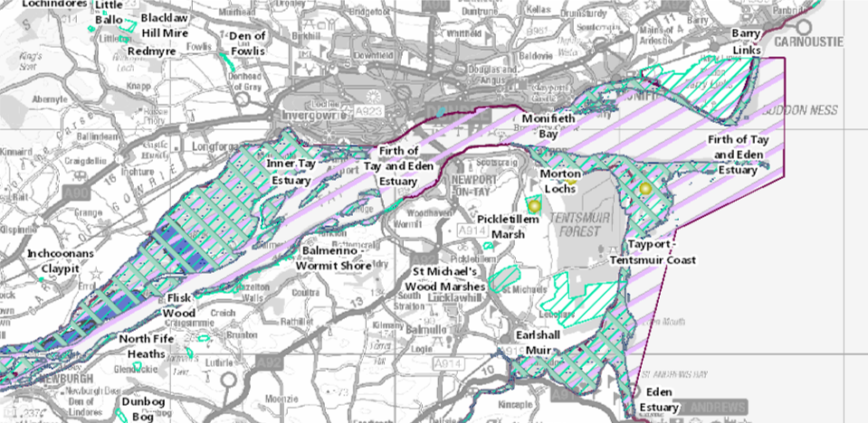

**Marine Designations**

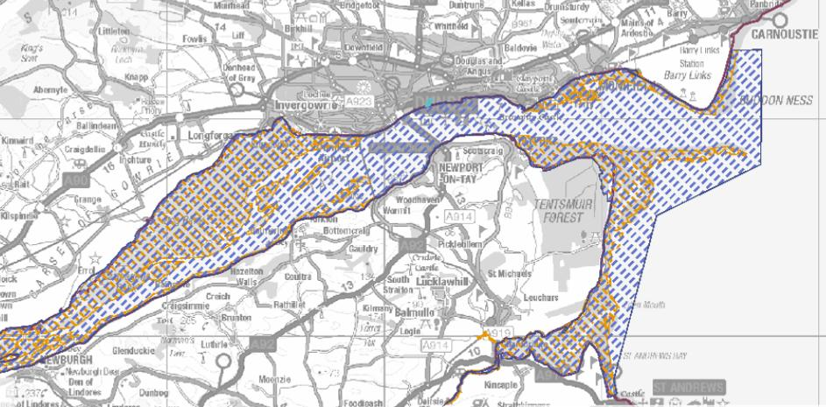

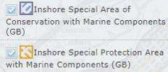

**Seabird Nesting Grounds**

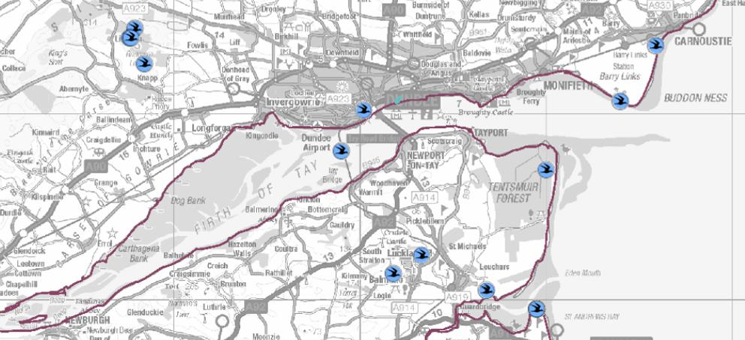

**Intertidal Foreshore Substrate**

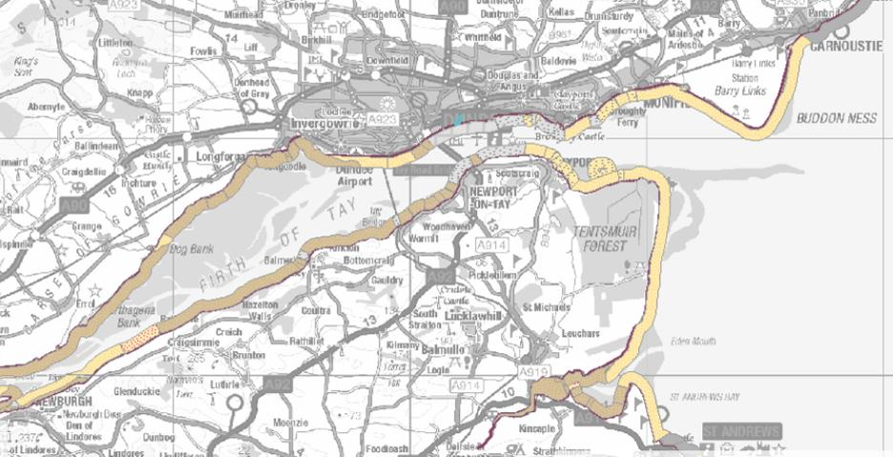

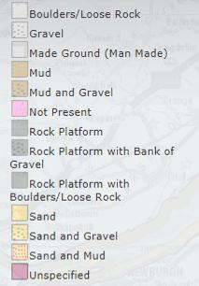

**Overview of Sites of Special Scientific Interest, Special Areas of Conservation and Special Protection Areas**

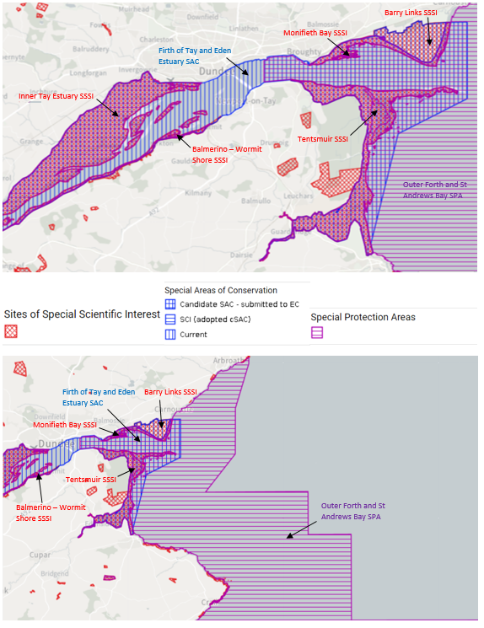

Response Assist List – All incidents / Pollution / Flooding or Grounding / Terror related or Bomb threat

* Commence Log? ☐
* Identify risks and hazards ☐
* In the event of an oil spill activate Dundee OPRC? ☐
* Is Pipeline response procedure being followed? ☐
* POLREP? ☐
* Has MSDS Sheet been obtain for spilled product ☐
* Have lines of communication been established? ☐
* Are there any casualties on board? ☐
* Emergency services alerted? ☐
* Type/Location of vessel established? ☐
* Ascertain other type of vessels able to assist? ☐
* Consider Masters Actions? ☐
* Is vessel to be evacuated? ☐
* Search & Rescue activated? ☐
* Is there type of terror threat / scenario? ☐
* Activate bomb disposal unit? ☐
* Bomb threat checklist if applicable? ☐
* Are Radio communications suspended? ☐
* Has a landing area been established for crew/casualties? ☐
* Pollution evident/immanent? ☐
* Activate Call Out System? ☐
* Set-up exclusion zones ☐
* Have the necessary security arrangements been made? ☐
* Possible port closure? ☐
* Is there a port of Refuge? ☐
* Evacuation of effected areas?
* Are there volatile substances/terminals in the vicinity? ☐
* Are there any volatile substances on board? ☐
* Effect on other traffic? ☐
* Suspend river traffic? ☐
* Establish position of incident? ☐
* Establish the nature of the seabed ☐
* Vhf emergency navigation broadcast? ☐
* Response Assist List – All Incidents / Flooding or Grounding / Pollution / Fire / Terror related or Bomb Threat
* COLREG sound signal/visual displayed ☐
* Public announcements made? ☐
* SITREP? ☐
* Obtain Meteorological, tidal & daylight hours data? ☐
* Is pilotage available/required? ☐
* Establish vessel details & status? ☐
* What cargo/bunkers does the vessel have on board? ☐
* Damage assessment of the vessel? ☐
* Establish Cause of event fire/flooding/etc? ☐
* Establish quantity & Type of release? ☐
* Has MSDS for oil released been requested
* How is the stability of the vessel affected? ☐
* Is HAZMAT information available? ☐
* Vessel secure & operations suspended ☐
* Ascertain whether vessel is able to manoeuvre ☐
* Has the vessel lost any cargo ☐
* Towage requirements/availability ☐
* Are tugs with pollution equipment available? ☐
* Consider Media statement (as Per Appendix7)? ☐
* Source landing areas for landing casualties? ☐
* Decontamination process commenced ☐
* Vessel evacuation process? ☐
* Effect of incident on crew/public assessed ☐
* Surrounding vessels/persons warned/notified? ☐
* Muster points for services / on scene commanding? ☐
* Medical triage considered? ☐
* Consider MAIB requirements? ☐
* Consider SOSREP involvement? (Possible salvage)? ☐

## Appendix 3- Emergency Contacts Directory

The Contact Directory has been removed from this plan.

All Emergency Contact details can now be found in the stand-alone document - Forth Ports Limited Emergency Contacts Directory. This directory is held on the Forth Ports Intranet. Additionally a paper copy is held by the primary plans with the Plans he