FORTH PORTS LIMITED

NTM No 01 of 2025 17th January 2025

NOTICE TO MARINERS
FIRTH OF TAY

VIRTUAL AIS BUOYED CHANNEL

Mariners are advised that the virtual AIS buoys between Lady Shoal and Horseshoe Buoy have been shifted to facilitate deep drafted vessels under pilotage. Buoys are positioned as follows and as illustrated in the chartlet below:
LS1 | 56°27.352'N | 2°46.587'W
LS2 | 56°27.256'N | 2°46.563'W
LS3 | 56°27.312'N | 2°47.115'W
LS4 | 56°27.216'N | 2°47.098'W
LS5 | 56°27.272'N | 2°47.643'W
LS6 | 56°27.175'N | 2°47.633'W
LS7 | 56°27.268'N | 2°49.123'W
LS8 | 56°27.171'N | 2°49.122'W
LS9 | 56°27.266'N | 2°49.728'W
LS10 | 56°27.169'N | 2°49.727'W

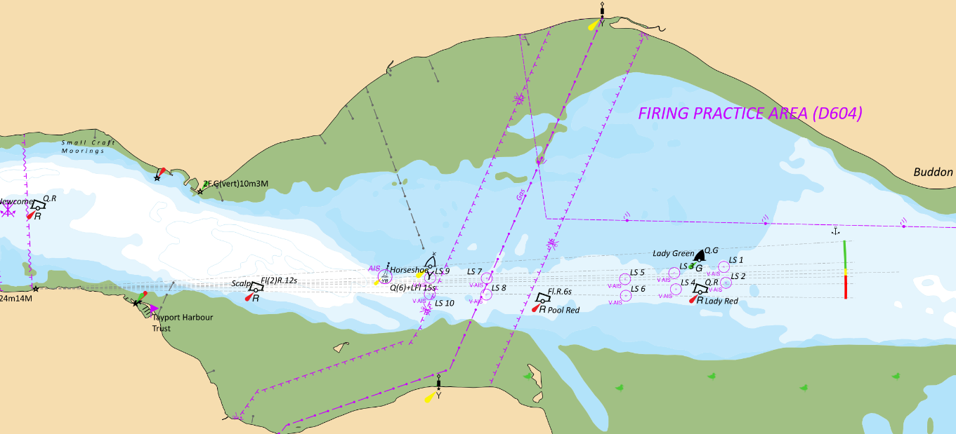

Status of previously published notices:

15/2024, 18/2024, 31/2024 and 32/2024 remain in force

Issued by:

Andrew Blake
Marine Manager Dundee

